SPORT

Football

**Premier League predictions: Jones Knows wants to back Alejandro Garnacho to score in a Manchester United win**

Match highlights of every Premier League game to be shown on the Sky Sports website and app just after full-time; watch Brighton vs Aston Villa and Fulham vs Manchester United live on Sky Sports

**Lewis Jones**

[@\_LJones\_](http://twitter.com/@_LJones_)

Saturday 12 November 2022 20:33, UK

**As the curtain temporarily comes down on the Premier League, Jones Knows takes to the prediction chair and thinks Alejandro Garnacho can star for Man Utd at Fulham.**

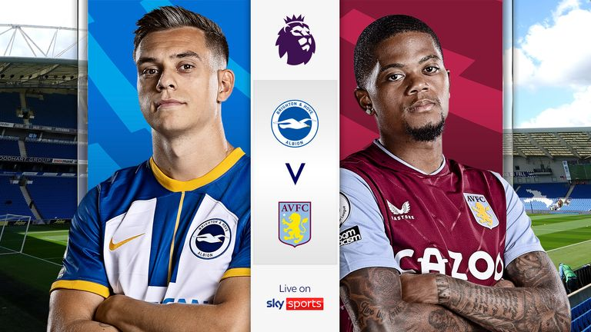

Assessing changes to how a team plays under a new manager can be profitable if noticing a new trend before the markets do. One area that interests me with Aston Villa is the much higher line Unai Emery is deciding to play with the defence which in turn is going to see opposition players caught offside at a higher rate than what has gone before.

During his spell in charge of Villarreal, Emery's team ranked second in La Liga for catching teams offside and Aston Villa are going the same way looking at the first two fixtures he has overseen against Manchester United, who were caught offside 11 times with eight of those coming in the 4-2 at Old Trafford.

I'd expect the same approach at The Amex, so having a look at the player offsides markets for Brighton - in what should be an enjoyable game to watch - is an angle to consider. Solly March (Evens) and Leandro Trossard (6/4) are priced up pretty favourably for one or more offsides, but Kaoru Mitoma at 4/1 with Sky Bet - if he starts - is the player to concentrate on. Although he is yet to be caught offside this season, he does play very high up against the full-back and does make runs in behind.

**Pick your England starting XI for World Cup 2022**

Pick your starting XI for England's opening World Cup game against Iran on November 21 using our interactive team selector

Thursday 10 November 2022 14:48, UK

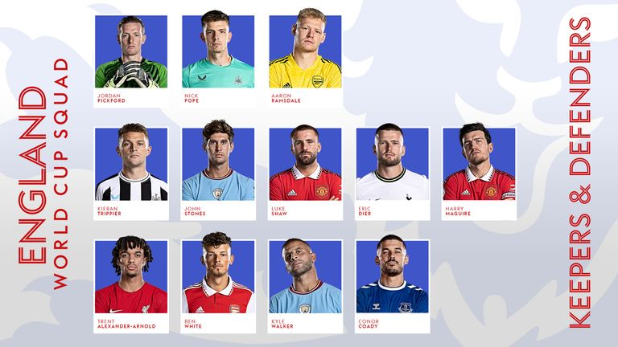

So, what would your England starting XI look like if the World Cup started today and all players were available? Use our interactive selector to pick your team below, screenshot your selections and share on Twitter [**@SkyFootball**](https://twitter.com/SkyFootball).

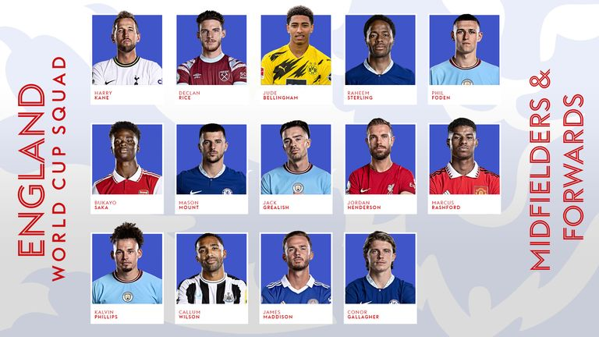

**Goalkeepers**: Dean Henderson, Nick Pope, Aaron Ramsdale.

**Defenders**: Trent Alexander-Arnold, Ben White, Conor Coady, Eric Dier, Harry Maguire, Luke Shaw, John Stones, Kieran Trippier, Kyle Walker.

**Midfielders**: Jude Bellingham, Mason Mount, Kalvin Phillips, Declan Rice, Jordan Henderson, Conor Gallagher, James Maddison.

**World Cup 2022: Injured stars ruled out or doubts to make it to the tournament in Qatar**

World Cup 2022 takes place in Qatar from November 20 to December 18; England face Iran on the second day of the tournament while Wales face USA; Wales vs England on November 29

Pogba injured his knee in pre-season and went under the knife in September to repair a damaged meniscus. The 29-year-old resumed training but on October 31 his agent said the midfielder would not return to action for Juventus nor the world champions before the World Cup.

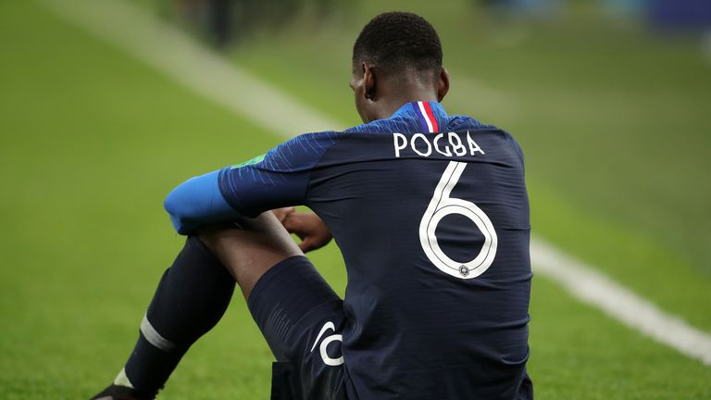

Image:Paul Pogba won't be going to Qatar due to a knee problem

England have injury concerns of their own with [**Reece James ruled out after failing to recover from a knee injury in time**](https://www.skysports.com/football/news/11095/12742376/reece-james-chelsea-and-england-defender-will-miss-world-cup-in-qatar-due-to-injury) while **Kyle Walker**and**Kalvin Phillips** are still working their way back to fitness as the World Cup gets ever closer.

Chelsea defender [**Ben Chilwell has confirmed he will miss the 2022 World Cup**](https://www.skysports.com/football/news/11095/12736989/ben-chilwell-chelsea-defender-expected-to-miss-world-cup-with-hamsgtring-injury) after suffering a significant injury in Chelsea's win over Dinamo Zagreb.

South Korea's **Heung-Min Son**was another player thought to be in a raceagainst time to be fit for the World Cup.

The Tottenham forward has undergone surgery to stabilise a fracture around his left eye after sustaining the injury in his side's 2-1 win over Marseille on Tuesday, and while Spurs gave no timeframe for the 30-year-old's recovery, [**he has now confirmed he is fit**](https://www.skysports.com/football/news/11095/12742604/heung-min-son-tottenham-forward-confirms-he-is-fit-for-the-world-cup-with-south-korea-after-surgery-around-fractured-eye).

# Manchester United into play-off while Arsenal top group - how the Europa League group stage finished

Man Utd finished second in Group E and face play-off against third-placed Champions League side in February; Arsenal claimed top spot in Group A and progress directly to round of 16; Jose Mourinho's Roma also head into play-offs after coming second to Real Betis in Group C

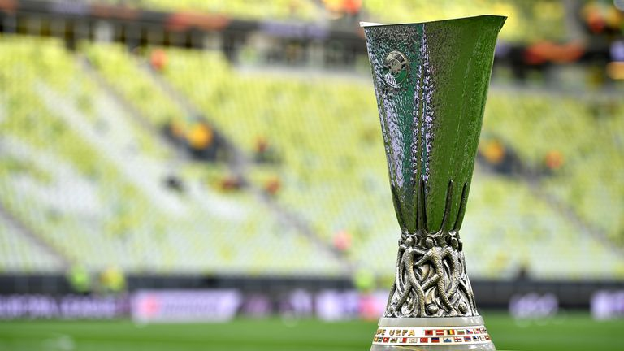

**Manchester United and Arsenal qualified from their Europa League groups but Erik ten Hag's side now face a play-off in February after failing to finish top.**

United needed to beat Real Sociedad by two clear goals in Spain on Thursday to secure first place in Group E but could manage a [**1-0 win**](https://www.skysports.com/football/news/26806/12737330/real-sociedad-0-1-manchester-united-alejandro-garnachos-first-senior-goal-in-vain-as-hosts-top-europa-league-group), meaning they will play a two-legged tie against one of the eight third-placed sides to have exited the Champions League.

Arsenal will be able to sit out the play-off round, though, after [**seeing off Zurich 1-0**](https://www.skysports.com/football/arsenal-vs-fc-zurich/report/477526) on the final matchday to secure first place in Group A.

Roma will join United in the play-offs after Jose Mourinho's side came from behind to beat Ludogorets at home on Thursday to claim second place in Group C.

**Atletico Madrid knocked out of Europe: Diego Simeone under pressure after 'darkest night' of his reign**

Atletico Madrid lost all three away games in a single Champions League group stage for the first time in their history; Atletico are winless in their last five Champions League games – their longest run without a victory in the competition since December 2009

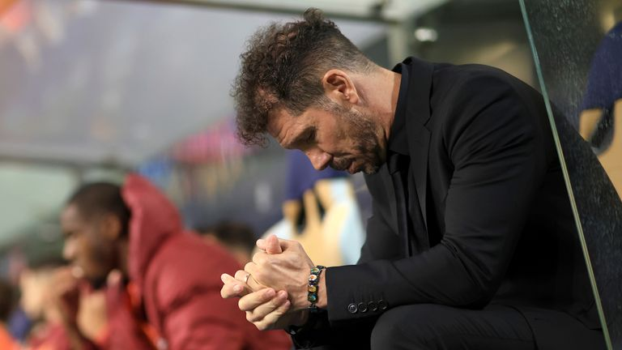

Image:Diego Simeone sits on the bench at Porto

**Diego Simeone sat motionless in the away dugout. His Atletico Madrid side were plumbing new depths at the Estádio do Dragão, but the most damning aspect was the sense of apathy in their typically charismatic head coach.**

With 23 minutes remaining, it looked as though Antoine Griezmann had given Atletico a lifeline with a well-taken goal to halve the deficit against Porto, but referee Daniele Orsato deemed there to have been a foul by Rodrigo De Paul on Galeno in the build-up.It was an extremely harsh decision with both players reaching the ball at the same time, but the Italian official immediately blew up for an infringement. Tensions boiled over on the pitch as De Paul and Fabio Cardoso were both cautioned, but Simeone barely flinched on the sidelines. There would be no berating of the fourth official Davide Massa. Just a broken figure in all black, downbeat and dressed at his side's funeral.The game was already up for El Cholo, for whom salvaging a Europa League spot might well still be viewed as a booby prize in these days of the Europa Conference League and endless football.In order to salvage a Europa League spot, Atletico only had to match Bayer Leverkusen's result against Club Brugge, but defeat meant they finish in bottom spot in Group B.

### There will be no European football after Christmas

Image:There will be no European football after Christmas

For Simeone, a serial winner as a player who lives and breathes the game, there was just a deep exhalation at another decision going against him.

**BOXING**

**Ricky Hatton returns to the ring for exhibition with Mexican legend Marco Antonio Barrera in Manchester**

Ricky Hatton, an icon of British boxing, reminded the Manchester faithful of some of the magic of old as he boxed an exhibition with Mexican boxing legend Marco Antonio Barrera

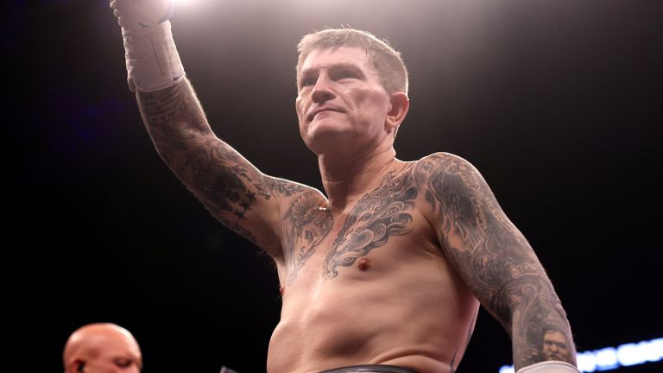

Image:Ricky Hatton put on the gloves one last time to say goodbye to his Manchester faithful

**Ricky Hatton returned to the ring to face fellow boxing legend Marco Antonio Barrera in an exhibition at the AO Arena in Manchester on Saturday.**

"There's only one Ricky Hatton." The chant reverberated around the stands before the man himself had even appeared for one last time at his beloved Manchester Arena.

The venue had been the site of some of his greatest nights, including his historic victory over Kostya Tszyu, as well as a bitter comeback that ended in defeat to Vyacheslav Senchenko 10 years ago.

But this occasion was not a comeback. It was an exhibition, really a celebration so Hatton and his fans could remember the good times one last time. They could cheer for their hero and sing 'Blue Moon' once again as Hatton made his iconic ringwalk.

In Marco Antonio Barrera, a legend of Mexican boxing himself, Hatton had a real friend and the ideal foil for this eight two-minute round exhibition with 16-ounce gloves and without a winner or a loser.

What it did have was a lot of noise and a deafening roar went up as Hatton held his arms up to his crowd.

In a nice touch veteran referee Mickey Vann came out of retirement to be the man in the middle one last time himself.

He wasn't given much to do as Hatton manoeuvred on to the front foot and began to ply Barrera with jabs, push him back and look for a trademark punch to the body.

Barrera is now 48 years old, to Hatton's 44, but hadn't entirely forgotten himself as a fighter, bringing Hatton on to a short but flush right before the end of their first round.

Hatton whipped a left hook across to the chin, only for Barrera to screw his lead uppercut into the Mancunian's jaw.

Neither was losing control but each wanted to remind the other that there was a real, if old, fighter still in there.

Hatton saw an opening for his right hook and flung that with gusto. He began to inject more power into his punches, his face set in a serious scowl even as a band in the crowd led the cheers around him

Hatton saw an opening for his right hook and flung that with gusto. He began to inject more power into his punches, his face set in a serious scowl even as a band in the crowd led the cheers around him

He worked Barrera suddenly on the ropes and would put him under pressure. Barrera summoned up his reserves to catch out Hatton with the occasional response.

They traded meaty punches in the last round too, each making sure to finish with a flourish as they let their hands go.

**Sunny Edwards outpoints Felix Alvarado to retain IBF flyweight title and unbeaten record, wants Jesse Rodriguez next**

Britain's Sunny Edwards takes his record to 19-0 with victory over Felix Alvarado in Sheffield; 26-year-old overcame spirited comeback from his opponent to win via unanimous decision and is now targeting a fight with WBC super-flyweight champion Jesse Rodriguez

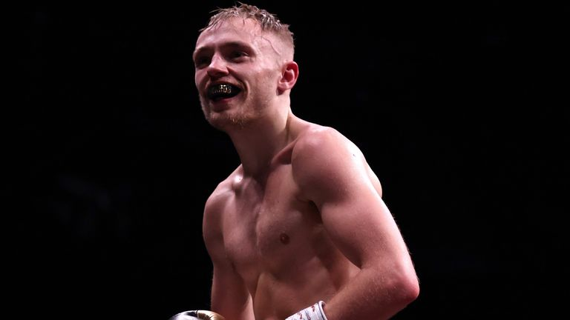

Image:Sunny Edwards took his record to 19-0 after outpointing Felix Alvarado to retain his IBF flyweight title

**Sunny Edwards retained his IBF flyweight title and preserved his unbeaten record with a unanimous decision victory over Felix Alvarado in Sheffield.**

The Londoner is now 19-0 after outpointing Nicaraguan fighter Alvarado, with the judges scoring the bout 115-113, 115-113, 116-112 in Edwards' favour.

Edwards, 26, called out WBC super-flyweight champion Jesse Rodriguez after his victory - and also said that WBC flyweight title holder Julio Cesar Martinez was "running scared" of him.

Edwards' Friday-night challenger Alvarado came into the fight with 33 knockout victories across his 38 wins.

However, the Briton boxed in confident fashion, with a crisp right uppercut in the fifth round and venomous left hook at the end of the sixth particular highlights and the latter shot leaving Alvarado dazed.

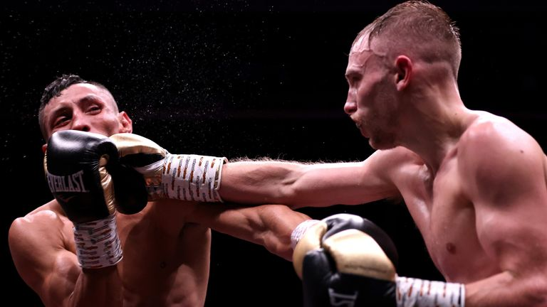

Image:Edwards (right) saw the fight scored 115-113, 115-113, 116-112 in his favour

Alvarado responded in the second half of the fight, landing a powerful body shot in the seventh, while Edwards dropped to the canvas after being accidentally tripped when referee Steve Gray stepped on his ankle.

Edwards regained control at the backend of the contest to complete a points victory.

**Jarrell Miller granted provisional boxing licence by Nevada State Athletic Commission**

Jarrell Miller was previously suspended in 2020; Miller was also denied a licence to fight Anthony Joshua by the New York State Athletic Commission in 2019

Tuesday 1 November 2022 19:53, UK

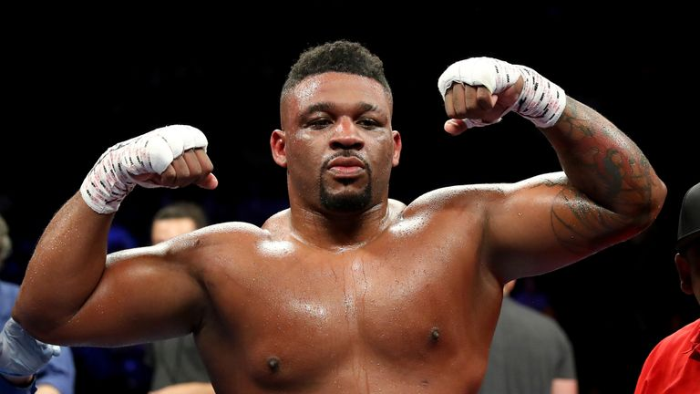

Image:Jarrell Miller has been cleared to fight in Las Vegas in the next few months

**Jarrell Miller has been granted a provisional boxing licence by Nevada State Athletic Commission.**

Miller was previously suspended ahead of his scheduled fight on July 9, 2020 against Jerry Forrest by the Nevada State Athletic Commission.

Miller denied "willingly" taking a performance-enhancing drug after reports of a failed drug test ruined plans for the bout in Las Vegas.

The Brooklyn heavyweight was also denied a licence to fight Anthony Joshua by the New York State Athletic Commission in 2019, following an adverse finding from a drugs test in March of the same year.

Miller admitted he "messed up" in a contrite video message posted on Instagram, saying he would "come back better".

Miller's participation for his Joshua bout was already under threat after the Voluntary Anti-Doping Association (VADA) informed both camps of an adverse finding in a drug-testing sample, leading to him being denied a licence for the date at Madison Square Garden.

The unbeaten 34-year-old resumed his career earlier this year with two low-profile wins in Buenos Aires and Tennessee.

**Katie Taylor takes clear unanimous decision over Karen Elizabeth Carabajal to defend undisputed lightweight championship**

Katie Taylor outclasses Karen Elizabeth Carabajal to defend the unified WBO, WBA, WBC and IBF lightweight titles, winning 100-91, 99-91 and 98-92 for the three judges; Whether it's an Amanda Serrano rematch or not, Taylor demands a stadium fight in Ireland next

Sunday 30 October 2022 13:32, UK

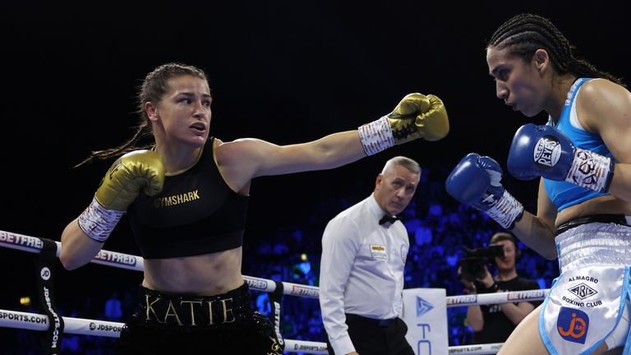

Image:Katie Taylor beats Karen Elizabeth Carabajal in London (Photos: Mark Robinson/Matchroom Boxing)

**Katie Taylor outpointed challenger Karen Elizabeth Carabajal to defend the undisputed lightweight championship at Wembley Arena in London on Saturday night.**

Irish star Taylor was a wide unanimous victor, securing the decision 98-92 for judge Bence Kovacs, 99-91 for Karoline Puetz and by a 100-91 shutout on Victor Loughlin's card.

Carabajal had been undefeated in 19 bouts before meeting Taylor. But she had never previously boxed outside of Argentina and had never fought anyone at the champion's level. She was ultimately outclassed.

Taylor, who turned professional at this same venue in 2016, showed superior hand speed, footwork and greater accuracy, and pressed home her advantage in the second half of the bout.

Carbajal felt the full weight of Taylor's punches in round five as the Irishwoman's timing improved and a left-right combination had the South American grimacing.

Taylor displayed her full range of skills in the seventh round and underlined her superiority with three more unanswered punches. In the eighth Carbajal was knocked off balance by two quick left hooks.

Carbajal came out swinging in the penultimate ninth round and was cut on the right side of her face following an accidental clash of heads.

**Dalton Smith targets Josh Taylor, Jack Catterall and a place 'in the history books' | Taylor gives his verdict on Smith's potential**

British champion Dalton Smith intends to go all the way and join Josh Taylor and Jack Catterall at the summit of their weight class; Kaisee Benjamin will provide a crucial test of those ambitions on November 12, live on Sky Sports; plus Taylor gives his verdict on Smith's potential

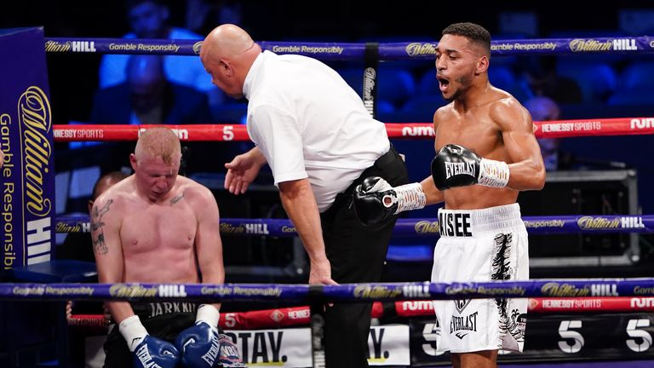

Play Video - 'This is a real fight!' | What danger does Benjamin pose to Smith?

Gary Logan and Andy Scott preview Dalton Smith's upcoming bout against Kaisee Benjamin, with Smith admitting it will be a 'dangerous' fight

**British champion Dalton Smith intends to join Josh Taylor and Jack Catterall at the top of the super-lightweight division.**

His ambitions though all depend on defending his title against Kaisee Benjamin at the Manchester Arena on November 12, live on *Sky Sports*.

"I'm probably in one of the hardest divisions and there's plenty of fights out there for me. I'm always going to be in good fights. I'm never going to be short of dance partners. The future looks bright. There's some big fights out there," Smith said.

He expects Benjamin to be aggressive and seek to pressurise him in next month's title clash.

"That will play to my hands. The pressure fighters I've fought who come forward - that's when you see me at my best," Smith told Sky Sports.

"He's a good fighter, he's experienced as a professional now. But he's nothing I haven't seen before. Obviously I respect him, I've got to be 100 per cent going in there but I feel like anything that Kaisee tries to do I'm going to have an answer for it.

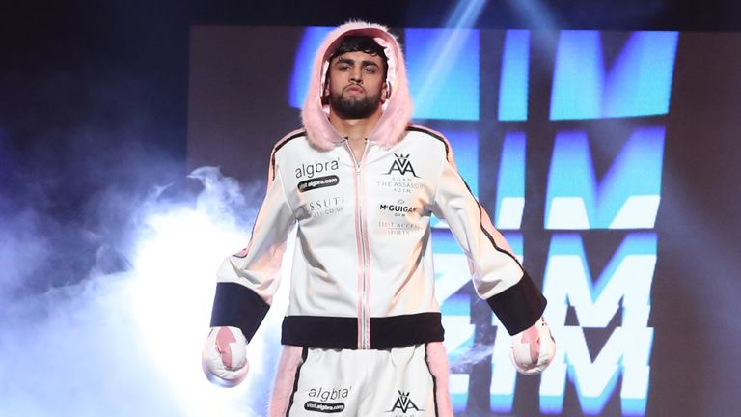

Play Video - Dalton Smith: I'm a fan of Azim | I want him to keep winning!

Dalton Smith shares his thoughts on Adam Azim and reveals how he and Azim sparred Luke Campbell ahead of his fight against Ryan Garcia in 2021

"We'll see. The main thing is what happens that first round and how they come out. I'm always prepared for anything. I can adapt. I'm not really sure Kaisee can adapt as much. So we'll see.

## **TENNIS**

## **Draper misses out on place in final at Next Gen ATP Finals**

Britain's Jack Draper missed out on a place in the final of the Next Gen ATP Finals after losing in four sets to Brandon Nakashima in Milan.

Draper hit back from losing the first set on a tie-break to take the second 4-1, the 20-year-old left-hander producing a stunning array of passing shots against his American opponent.

However, Nakashima broke in the sixth game of the third set to take it 4-2 and reeled off five straight points from 5-2 down in the fourth set tie-break to seal an impressive win.

Nakashima will take on Czech Jiri Lehecka in the final after Lehecka defeated Switzerland's Dominic Stricker in four sets in the first semi-final.

"It was very high quality from both of us the whole match," Nakashima told the ATP Tour's website.

"I was fighting for every point and I was happy to close it out at the end. We have both had a great year and both had great wins against top players.

"I knew it was going to be a tough match, he has a great lefty serve. I knew I had to be quick on my feet. I am happy I played well. I have a lot of confidence in my game right now."

Nakashima, who beat Lehecka in the group stages, added: "I am going to try and forget about our match a couple of days ago. Jiri has been playing great all week, so I am sure it is going to be a tough one."

## **GB to face Spain and Australia at United Cup without Raducanu**

Great Britain will face Spain and hosts Australia at the new mixed team United Cup next month but will again be without Emma Raducanu.

The event sees the ATP and WTA Tours come together, with each tie comprising two men's singles matches, two women's singles and one mixed doubles.

Raducanu, who is sitting out this week's Billie Jean King Cup Finals through injury, has not entered and is set to play a regular tour event instead.

Britain's two leading men, Cameron Norrie and Dan Evans, have signed up and are joined by Harriet Dart, Katie Swan and doubles specialist Jonny O'Mara. Jan Choinski, Anna Brogan and junior Ella McDonald will offer back-up.

Britain's group matches will take place in Sydney, with other groups based in Perth and Brisbane.

World No 1 Carlos Alcaraz is not in the Spain line-up but they can boast three top-20 players in Rafael Nadal, Pablo Carreno Busta and Paula Badosa and will be favourites to progress to the semi-finals while Nick Kyrgios heads the Australian line-up.

Serbia are not among the 16 teams so far confirmed, with Novak Djokovic waiting to find out whether his ban from entering Australia will be lifted, while Canada are also notable absentees along with Russia and Belarus, who are ineligible.

The United Cup runs from December 29 to January 8.

## **Badosa leads Spain to victory over Kazakhstan**

Paula Badosa won on her Billie Jean King Cup debut as she battled past Kazakhstan's Elena Rybakina in three sets to secure victory for **Spain** in the Group C tie on Wednesday.

Badosa, currently ranked 13th in the world, won 6-2 3-6 6-4 over Rybakina, giving Spain a chance to go into the semi-finals if they defeat hosts Great Britain on Thursday.

"It was my first time and I think I enjoyed every minute on court," Badosa said.

In a late Group D match on Wednesday, Coco Gauff and Caty McNally beat Magda Linette and Alicja Rosolska 6-1 6-2 to earn the **United States**a 2-1 win over Poland, who are without world No 1 Iga Swiatek.

Belinda Bencic led **Switzerland** to victory over Italy in their opening tie, while **Slovakia** bounced back from a tough loss to Australia to defeat Belgium and get their campaign back on track.

The competition, formerly called the Fed Cup, was renamed in honour of the 12-times Grand Slam champion and restructured into a format concluding with 12 nations competing over one week for the title.

## **Garcia survives three-set epic to reach semis of WTA Finals**

Caroline Garcia survived an epic battle with Daria Kasatkina 4-6 6-1 7-6 (7-5), sending over 42 winners to claim the final spot in the semis of the WTA Finals on Saturday and set up a showdown with Greek star Maria Sakkari.

The Cincinnati winner had played some of the best tennis of her career this summer, reaching the US Open semi-final, and showed her fighting spirit was intact in Fort Worth, Texas, as she outlasted Kasatkina in a 32-point rally for match point.

**"Every match we say you have to give it all and no regrets, go for it, and its always true, but in this tournament even more," Garcia said.**

**"I really tried to give everything I had."**

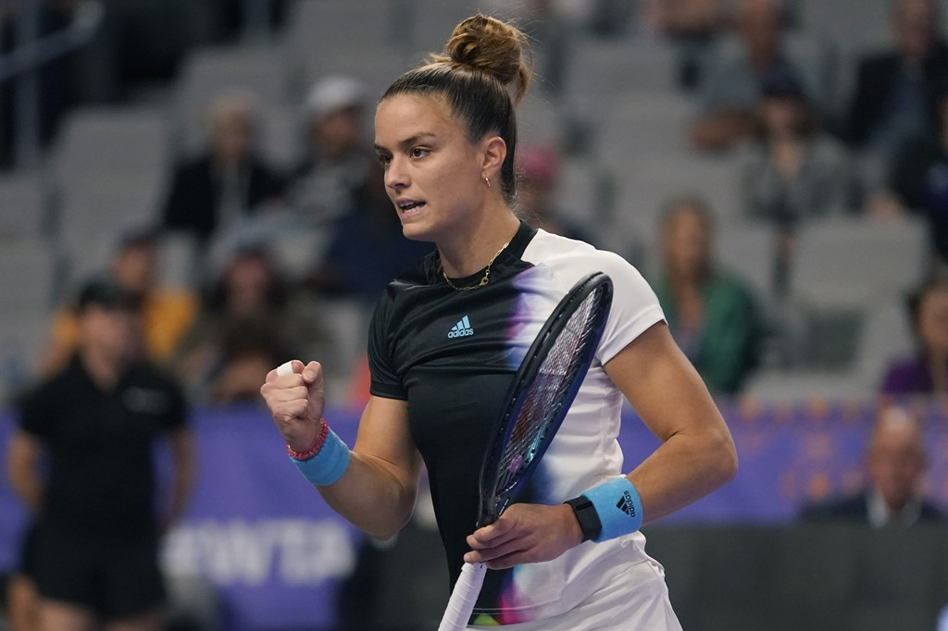

Featuring in the finals for the first time since 2017, she'll hope to be fully recovered for Sakkari, whom she beat in the fourth round at Cincinnati.

The world No 5 looks tough as ever, after flattening all three of her round robin opponents.

**"The last match in Cincinnati was a very tight one," said Garcia. "She's playing some great tennis. It will be a very different game as today."**

**Golf**

**Ladies European Tour: Chiara Noja stuns Charley Hull in play-off to win Aramco Team Series - Jeddah**

## Chiara Noja posts a round-of-the-day 65 and birdies both play-off holes to claim a maiden Ladies European Tour victory; overnight leader Charley Hull finishes second, with Nicole Garcia claiming third and also winning the team competition

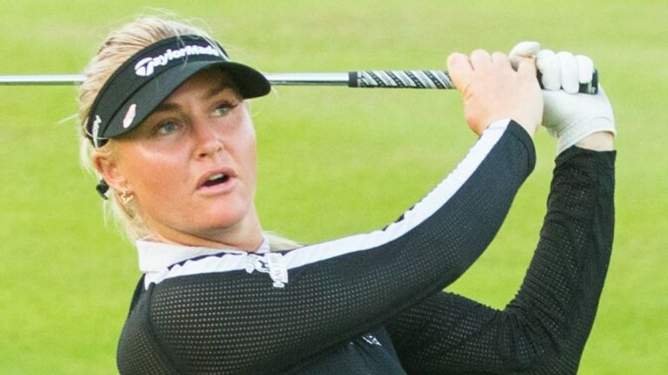

Charley Hull narrowly missed out on a fourth Ladies European Tour title

Charley Hull narrowly missed out an Aramco Team Series victory as 16-year-old Chiara Noja snatched a dramatic play-off win in Jeddah.

Hull, the overnight leader, posted a four-under 68 on the final day at Royal Greens Golf and Country Club to finish locked with Noja - who carded a round-of-the-day 65 - on 13 under.

The players returned to the par-five 18th for the play-off, where both players exchanged birdies before Noja secured her maiden Ladies European Tour title with a birdie on the second extra play-off hole.

### **How Noja stunned Hull in Saudi Arabia**

Noja opened with back-to-back birdies and eagled the par-five fourth, with the teenager picking up another shot at the seventh before bogeying the par-three next.

The German youngster responded with three birdies in a four-hole stretch around the turn and moved ahead when she holed from 20 feet at the 16th, although stuttered slightly with a bogey at the next and failed to birdie the par-five last.

Hull had reached the turn in level-par but charged back into contention with four birdies in a five-hole stretch from the 13th, while a closing par saw her tied with Noja after 54 holes.

The Englishwoman holed from eight feet to match Noja's two-putt birdie on the first extra hole, although she ran off the back of the green with her approach on the second extra hole after almost holing out from the rough for albatross.

Hull was unable to get up and down from the back of the green, missing her birdie try from 15 feet, as Noja reached the putting surface in two and two-putted for the winning birdie.

A final-hole eagle saw Nicole Garcia post a five-under 67 and finish a shot back in third ahead of Virginia Elena Carta, who carded a final-round 69, while Bronte Law shared fifth spot on 10 under with Lee-Anne Pace.

# Tiger Woods confirms return at Hero World Challenge in first tournament since The 150th Open

## **Tiger Woods hasn't played since missing the cut at The Open in July - one of three official starts in 2022 (The Masters and PGA Championship). He has not played at the Hero World challenge since 2019**

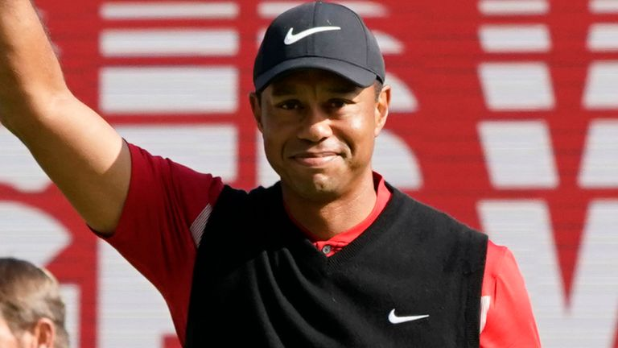

Tiger Woods is set to return to action

Tiger Woods has announced he will return to action at this year's Hero World Challenge in his first outing since The 150th Open in July.

The 15-time major champion took to Twitter to confirm his involvement in the 20-man tournament which is due to take place from December 1-4 in Albany.

Woods, who has won the self-hosted PGA Tour event five times in the past, is joined by Kevin Kisner and Tommy Fleetwood in making up the three remaining unfilled spaces.

He has been caddying for son Charlie this week and recently confirmed he will take part in "The Match", a 12-hole exhibition, with Rory McIlroy, Jordan Spieth and Justin Thomas on December 10.

Beyond that, he is also expected to compete at the PNC Championship alongside Charlie in what could prove a busy finish to a limited 2022 schedule on the back of his recovery from a career-threatening car crash.

Woods missed the cut at the historic St Andrews's in Scotland earlier this summer on an emotional return to the links where he has won twice in 2000 and 2005.

The 46-year-old's three outings this year have come by way of majors that saw him place 47th after making the cut at The Masters before withdrawing from the PGA Championship.

He has not played in a regular PGA Tour event since finishing tied-72nd at the 2020 Zozo Championship.

# Rules of Golf: Modifications for golfers with disabilities among changes from 2023

## The creation of Rule 25 comes as the game's governing bodies continue their efforts to make golf more inclusive and sustainable, with 4m fewer copies of the rules being printed as the rules are promoted on a mobile app

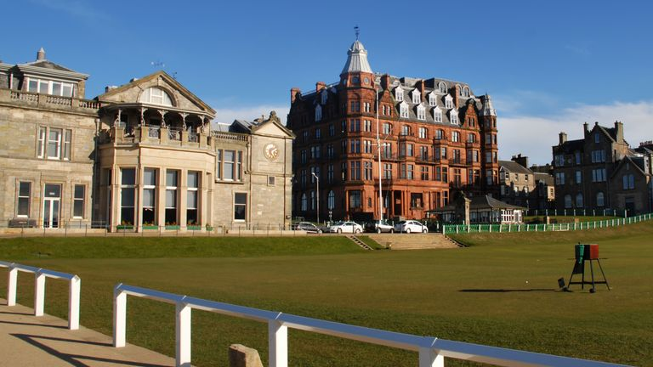

Modifications for players with disabilities will be fully incorporated into the Rules of Golf from 2023 as part of significant changes announced by the R&A and USGA.

The new rules, coming into effect from January 1 and part of efforts to make the game more inclusive and sustainable, will see modified rules for players with disabilities fully incorporated into the playing rules without the need to adopt a local rule.

Modifications as part of the creation of Rule 25 include allowing blind players to receive help with taking a stance and lining up for a shot, while amputees are allowed to anchor the club and get help to drop or replace their ball.

Governing bodies will also print 4m fewer copies of the rules, instead promoting them on a mobile app, while several penalties have been relaxed and language has been clarified to help golfers at all levels of play.

Grant Moir, Director of Rules at The R&A, said, "We are continuing to improve and adapt the Rules of Golf to ensure they are in line with the way the modern game is played. That means making the Rules easier to understand and access for all golfers and making the sport more inclusive and welcoming for golfers with disabilities.

"We are also working to ensure golf has a sustainable long-term future and making more resources available digitally is key to achieving that goal."

Other changes to the rules include allowing players to replace a club that is damaged during a round, provided it was not damaged through abuse, while a ball at rest must be replaced if it moves to "another area of the course" after being dropped, placed or replaced.

# Ting-Hsuan Huang qualifies for majors after winning Women's Amateur Asia-Pacific Championship

## Seventeen-year-old Ting-Hsuan Huang earns entry into AIG Women's Open and the Amundi Evian Championship in 2023 after two-stroke victory at Women's Amateur Asia-Pacific Championship in Thailand; Chinese Taipei player finishes two strokes clear of home favourite Natthakritta Vongtaveelap

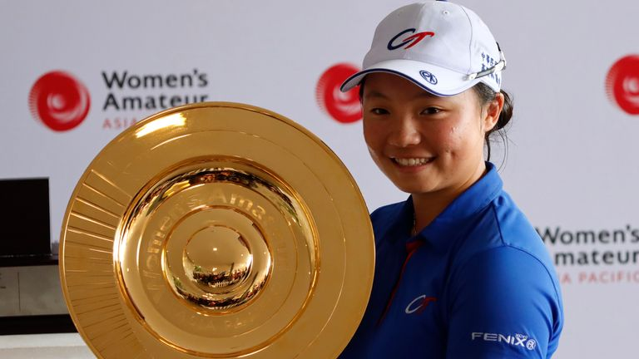

Ting-Hsuan Huang won the Women's Amateur Asia-Pacific Championship in Thailand to qualify for the AIG Women's Open and the Amundi Evian Championship in 2023

Ting-Hsuan Huang won the Women's Amateur Asia-Pacific Championship in Thailand to secure entry into two major championships in 2023.

Huang, 17, will now tee it up at the AIG Women's Open and the Amundi Evian Championship next year after a two-stroke win over home favourite Natthakritta Vongtaveelap at Siam Country Club.

Vongtaveelap was one under for her final round and nine under for the event, with her hopes dashed by bogeys at the 16th and 17th holes.

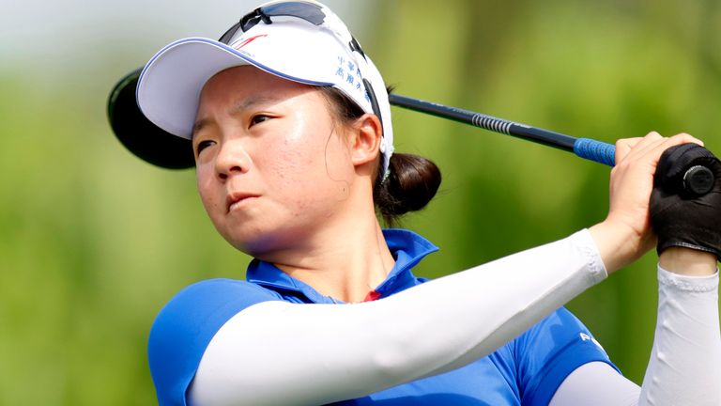

Huang says 'it is a dream come true' to be able to play in majors

Huang had bogeyed her first and fourth holes after starting the day in a share of the lead at eight under but recovered brilliantly to secure a win that has also earned her a spot in the Hana Financial Group Championship and an invitation to play in the Augusta National Women's Amateur.

Huang said: "To be able to play in majors is really a dream come true for me. I did not have any expectations coming into this week.

# Bermuda Championship: Winner Seamus Power wants to represent Europe at the Ryder Cup in Rome next September

## County Waterford golfer Seamus Power wins his second PGA Tour title as a closing 70 earned him a one-shot victory in the Bermuda Championship; "I play a lot of tournaments and it's going to take a little while to sink in"

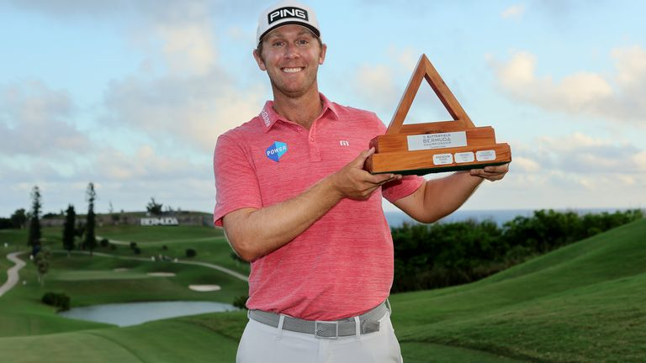

Seamus Power collected a second PGA Tour title at the Bermuda Championship

Ireland's Seamus Power boosted his Ryder Cup ambitions with a second PGA Tour title at the Bermuda Championship.

Power followed up three rounds of 65 with a final-day 70 to edge out Belgium's Thomas Detry by one shot.

"You're going to make some birdies on the front and I knew it was going to be really hard coming in.

"I made hard work of it in the end, but I'm delighted to get it done."

Power won the Barbasol Championship in 2021 and has made no secret of his ambition to represent Europe at the Ryder Cup in Rome next September.

The 35-year-old from County Waterford closed out victory despite bogeying the final hole when his approach shot slipped off the green's false front.

Power said: "It's a completely different feeling (to the first win) but it's just as special. I play a lot of tournaments and it's going to take a little while to sink in."

Detry finished with birdies on 17 and 18 to push Power all the way with a closing round of 70.

# Bermuda Championship: Ben Crane takes single-shot lead after his lowest PGA Tour score in 10 years

## Ben Crane's round of 62 puts the 46-year-old at the top of the leaderboard after the second round of the Butterfield Bermuda Championship; watch the live action on Sky Sports Golf from 6.30pm on Saturday

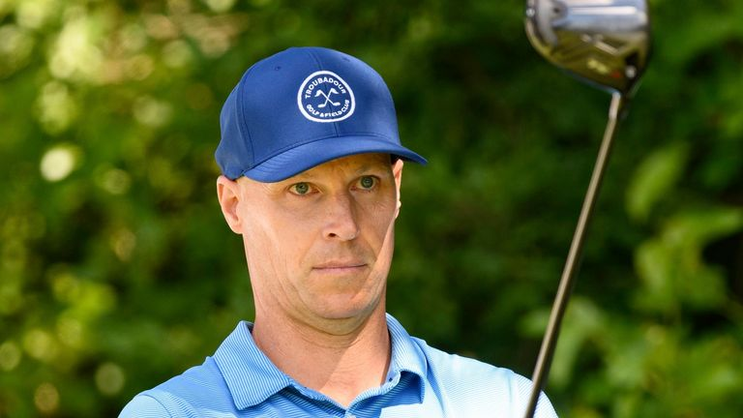

Ben Crane leads by a single shot at the Bermuda Championship after his nine-under 62

Ben Crane recorded a nine-under 62 – his lowest score in a decade – to take a one-shot lead going into the weekend at the Butterfield Bermuda Championship.

Crane holed out with a wedge for eagle to complete a back nine of 29 and equal his career low on the PGA Tour, edging him in front of a cluster of rivals.

The 46-year-old, who was given a sponsor exemption for the Bermuda tournament, has not registered a victory since the 2014 FedEx St Jude Championship - and had gone five years without leading after any round.

"Obviously I played the best golf I've played in a long time and to be in this tournament is super encouraging," said Crane.

"I don't get in a lot and the weather starts getting bad right when I finished, so it was really cool to shoot 62.

"That 29 on the back, I didn't see it coming, but it adds up to 29 - a super fun day."

Crane, who was at 14-under 128, played alongside his good friend Aaron Baddeley, who had a 64 and was among five players to trail by a single shot.

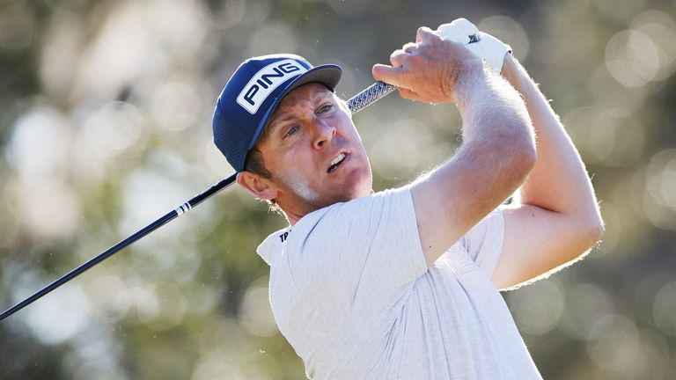

Ireland's Seamus Power is two shots off the lead

Also in that group were joint first-round leader Austin Smotherman, who was tied until a late three-putt bogey for a 67, Adam Schenk (66), Robby Shelton (66) and Ben Griffin (64).

# Cristiano Ronaldo leaves Manchester United by mutual consent following explosive interview with Piers Morgan

Man Utd issued a statement on Tuesday announcing they had reached a mutual agreement with Cristiano Ronaldo to terminate his contract; Ronaldo said: "I love Man Utd and I love the fans, that will never ever change. However, it feels like the right time for me to seek a new challenge"



**Dan Sansom**

[@DanSansom\_](http://twitter.com/@DanSansom_)

Tuesday 22 November 2022 22:37, UK

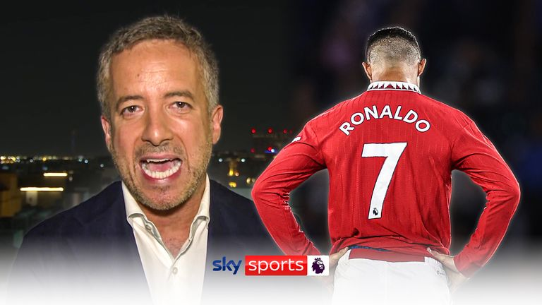

Play Video - Explained: What went wrong for Ronaldo & who could sign him?

Sky Sports News chief reporter Kaveh Solhekol explains what went wrong for Cristiano Ronaldo at Manchester United

**Cristiano Ronaldo has left Manchester United by mutual consent following his explosive interview with Piers Morgan.**

United issued a 67-word statement on Tuesday evening announcing they had reached a mutual agreement with the 37-year-old forward to terminate his contract.

Sponsored link

[Recommended by](https://www.outbrain.com/what-is/default/en)

**[[Photos] The Oldest Stars Who Are Still Living In 2022](https://mightyscoops.com/trending/these-golden-age-stars-are-still-around-and-enjoying-their-retirement-oldstarssamhobus?utm_source=outbrain&utm_campaign=0068cabfd40ca2571df0adc0dedd8b16e4&utm_medium=$section_name$__$section_id$&utm_term=%5BPhotos%5D+The+Oldest+Stars+Who+Are+Still+Living+In+2022&ts=$time_stamp$&tbv=$cpc$&pcl=1&utm_source=outbrain&utm_campaign=0068cabfd40ca2571df0adc0dedd8b16e4&utm_medium=$section_name$__$section_id$&utm_term=%5BPhotos%5D+The+Oldest+Stars+Who+Are+Still+Living+In+2022&ts=$time_stamp$&tbv=$cpc$&pcl=1&obOrigUrl=true" \t "_blank)**[https://mightyscoops.com/](https://mightyscoops.com/trending/these-golden-age-stars-are-still-around-and-enjoying-their-retirement-oldstarssamhobus?utm_source=outbrain&utm_campaign=0068cabfd40ca2571df0adc0dedd8b16e4&utm_medium=$section_name$__$section_id$&utm_term=%5BPhotos%5D+The+Oldest+Stars+Who+Are+Still+Living+In+2022&ts=$time_stamp$&tbv=$cpc$&pcl=1&utm_source=outbrain&utm_campaign=0068cabfd40ca2571df0adc0dedd8b16e4&utm_medium=$section_name$__$section_id$&utm_term=%5BPhotos%5D+The+Oldest+Stars+Who+Are+Still+Living+In+2022&ts=$time_stamp$&tbv=$cpc$&pcl=1&obOrigUrl=true" \t "_blank)

**[Melt Stubborn Fat Like Clockwork With this Simple Trick You Can Do From Home](https://healthyzelo.com/diet1-plastic-copy?utm_source=outbrain&utm_medium=diet_INTL3&utm_campaign=mobile&utm_term=$publisher_name$_$section_name$&cmc_tid=$ob_click_id$&obOrigUrl=true" \t "_blank)**[HealthyZelo.com](https://healthyzelo.com/diet1-plastic-copy?utm_source=outbrain&utm_medium=diet_INTL3&utm_campaign=mobile&utm_term=$publisher_name$_$section_name$&cmc_tid=$ob_click_id$&obOrigUrl=true" \t "_blank)

In the interview on TalkTV - aired in two parts on Wednesday and Thursday last week - [**Ronaldo said he felt "betrayed" by the club and has "no respect" for manager Erik ten Hag**](https://www.skysports.com/football/news/11667/12747058/cristiano-ronaldo-manchester-united-forward-says-he-feels-betrayed-and-has-no-respect-for-erik-ten-hag).

#### Ronaldo's key quotes - a snapshot of his full interview

* 'I feel betrayed by Man Utd | I have no respect for Erik ten Hag'
* 'Man Utd doubted me over my sick daughter when I missed pre-season'
* 'Glazer family don't care about Man Utd | United have stopped on a clock'
* 'Man City move was close but Sir Alex Ferguson changed everything'
* 'Youngsters don't care but Diogo Dalot and Lisandro Martinez are different'
* 'Roy Keane is the best captain I ever had but Gary Neville and Wayne Rooney are not my friends'
* 'I never saw Ralf Rangnick as the boss | Ole Gunnar Solskjaer did a good job'
* 'I regret leaving Old Trafford vs Tottenham - I felt provoked'
* 'I turned down €350m Saudi move | I don't know if I'll still be at Man Utd after World Cup'
* 'I would be happy if Arsenal win the Premier League'
* 'Lionel Messi is magic | I want to play until I'm 40'

The Portugal captain, who is currently representing his country at the World Cup, also claimed members of the United hierarchy were trying to force him out of Old Trafford and [**doubted him when he said he could not attend pre-season because his daughter was ill**](https://www.skysports.com/football/news/11667/12747639/cristiano-ronaldo-man-utd-doubted-me-over-my-sick-daughter-when-i-missed-pre-season) in hospital.

United said they would consider their response to Ronaldo's comments "after the full facts have been established" and have now decided to part ways with the five-time Ballon d'Or winner.

Sponsored Links

[Recommended by](https://www.outbrain.com/what-is/default/en)

**[If you own a mouse, you have to play this game. No Install. Play for free.](https://panzer.quest/?r=obnpq1wwv&clickid=$ob_click_id$&utm_source=outbrain-$publisher_name$-$section_name$&utm_medium=obnpq1wwv&utm_term=If+you+own+a+mouse%2C+you+have+to+play+this+game.+No+Install.+Play+for+f&obOrigUrl=true" \t "_blank)**[(Panzer.Quest strategy game)](https://panzer.quest/?r=obnpq1wwv&clickid=$ob_click_id$&utm_source=outbrain-$publisher_name$-$section_name$&utm_medium=obnpq1wwv&utm_term=If+you+own+a+mouse%2C+you+have+to+play+this+game.+No+Install.+Play+for+f&obOrigUrl=true" \t "_blank)

**[At 26.81%, LONGi sets a new world record efficiency for silicon solar cells](https://www.longi.com/en/news/propelling-the-transformation/?obOrigUrl=true" \t "_blank)**[(LONGi)](https://www.longi.com/en/news/propelling-the-transformation/?obOrigUrl=true" \t "_blank)

**[LONGi displays latest Hi-MO 6 series modules at COP27, releases 2nd White Paper on Climate Action](https://www.longi.com/en/news/white-paper-on-climate-action-2022/?obOrigUrl=true" \t "_blank)**[(LONGi)](https://www.longi.com/en/news/white-paper-on-climate-action-2022/?obOrigUrl=true" \t "_blank)

**[Unsold Cruise Cabins (Take a Look at the Prices)](https://redirectsystems.com/?mk=4ZFXuydgVt&ci=005cb5b34b02113c60b7a03f58daac3887&ad_id=004573ca1acbc717626ead9fff6842ddbf&site_id=$publisher_id$&section_id=$section_id$&adtitle=Unsold+Cruise+Cabins+%28Take+a+Look+at+the+Prices%29&timestamp=$time_stamp$&source=4&ct=Cruise&mp=ALL&ln=EN&click_id=$ob_click_id$&pixel_id=00bde8f68fde1ca3259af697944a42b88a&publisher_name=$publisher_name$&section_name=$section_name$&click_event=562Pixel&obOrigUrl=true" \t "_blank)**[(Cruise Offers | Search Ads)](https://redirectsystems.com/?mk=4ZFXuydgVt&ci=005cb5b34b02113c60b7a03f58daac3887&ad_id=004573ca1acbc717626ead9fff6842ddbf&site_id=$publisher_id$&section_id=$section_id$&adtitle=Unsold+Cruise+Cabins+%28Take+a+Look+at+the+Prices%29&timestamp=$time_stamp$&source=4&ct=Cruise&mp=ALL&ln=EN&click_id=$ob_click_id$&pixel_id=00bde8f68fde1ca3259af697944a42b88a&publisher_name=$publisher_name$&section_name=$section_name$&click_event=562Pixel&obOrigUrl=true" \t "_blank)

**[[Pics] Always Put a Plastic Bottle on Your Tires when Parked, Here's Why](https://rfvtgb.journalistate.com/worldwide/lifesa-ob?utm_source=outbrainjk&utm_campaign=js-lifesa-nc2-s10-des-0w-rl-21112d&utm_term=$section_name$&utm_medium=$section_id$&utm_bid=$cpc$&obOrigUrl=true" \t "_blank)**[(Journalistate)](https://rfvtgb.journalistate.com/worldwide/lifesa-ob?utm_source=outbrainjk&utm_campaign=js-lifesa-nc2-s10-des-0w-rl-21112d&utm_term=$section_name$&utm_medium=$section_id$&utm_bid=$cpc$&obOrigUrl=true" \t "_blank)

**[[Pic] Remember Him Wait Till You See Him Now](https://rfvtgb.interesticle.com/worldwide/wrestl-ob?utm_source=outbrainjk&utm_campaign=in-wrestl-nc0-des-0w-mm-23042d&utm_term=$section_name$&utm_medium=$section_id$&utm_bid=$cpc$&obOrigUrl=true" \t "_blank)**[(Interesticle)](https://rfvtgb.interesticle.com/worldwide/wrestl-ob?utm_source=outbrainjk&utm_campaign=in-wrestl-nc0-des-0w-mm-23042d&utm_term=$section_name$&utm_medium=$section_id$&utm_bid=$cpc$&obOrigUrl=true" \t "_blank)

## **Trending**

* [World Cup 2022 schedule, teams and draw](https://www.skysports.com/football/news/11095/12354033/world-cup-2022-schedule-teams-and-draw)
* [Glazers open to selling Man Utd | Club valued around £5bn](https://www.skysports.com/football/news/11667/12753492/glazers-open-to-selling-man-utd-club-valued-around-163-5bn)
* [Will Man Utd and Liverpool sales turn into bidding war?](https://www.skysports.com/football/news/11095/12753687/will-man-utd-and-liverpool-sales-turn-into-bidding-war)
* [Transfer Centre LIVE! Who should replace Ronaldo at Man Utd? Your thoughts](https://www.skysports.com/football/live-blog/20876/12476234/transfer-centre-live-who-should-replace-ronaldo-at-man-utd-your-thoughts)
* [Germany take FIFA to court over OneLove armband | Neuer could wear vs Spain](https://www.skysports.com/football/news/12098/12753559/germany-take-fifa-to-court-over-onelove-armband-neuer-could-wear-vs-spain)
* [Ronaldo leaves Man Utd | 'Right time for a new challenge'](https://www.skysports.com/football/news/11667/12753309/ronaldo-leaves-man-utd-right-time-for-a-new-challenge)
* [Papers: Saka set to treble wages and sign new Arsenal deal](https://www.skysports.com/football/news/11095/12753525/papers-saka-set-to-treble-wages-and-sign-new-arsenal-deal)
* [World Cup LIVE! Germany protest against freedom of speech violations](https://www.skysports.com/football/live-blog/12098/12717259/world-cup-live-germany-protest-against-freedom-of-speech-violations)
* [Guardiola signs two-year Man City contract extension](https://www.skysports.com/football/news/11095/12753075/guardiola-signs-two-year-man-city-contract-extension)
* [Ricciardo returns to Red Bull as third driver for 2023](https://www.skysports.com/f1/news/12433/12753863/ricciardo-returns-to-red-bull-as-third-driver-for-2023)
* [Video](https://www.skysports.com/watch/video)
* [Latest News](https://www.skysports.com/news-wire)

It is understood a settlement fee was not part of the termination. "I'm told there wasn't a payout so United are saving about £16m," said Sky Sports News senior reporter Melissa Reddy.

According to Sky Sports News chief reporter Kaveh Solhekol, there is a sense of relief at the club that the issue has been finally sorted and a feeling the team will be in a stronger position in the second half of the season.

### Also See:

**[What went wrong for Ronaldo at Man Utd?](https://www.skysports.com/watch/video/sports/football/12753349/explained-why-cristiano-ronaldo-left-manchester-united)**

**[Transfer Centre LIVE! Where next for Ronaldo?](https://www.skysports.com/transfer-centre)**

**[Ronaldo: I feel 'betrayed' by Man Utd | 'No respect for Ten Hag'](https://www.skysports.com/football/news/11667/12747058/cristiano-ronaldo-manchester-united-forward-says-he-feels-betrayed-and-has-no-respect-for-erik-ten-hag)**

**[Ronaldo interview reveals his failure to accept his own decline](https://www.skysports.com/football/news/11667/12749780/cristiano-ronaldo-interview-analysed-man-utd-revelations-insignificant-as-players-own-failure-to-adjust-is-laid-bare)**

**[Get Sky Sports](http://www.sky.com/shop/tv/sports?dcmp=ssf.com_bul_shop)**

**[Download the Sky Sports App](https://www.skysports.com/football/news/11677/12572660/download-the-sky-sports-app-premier-league-goals-f1-race-control-and-more-at-your-fingertips)**

* [**Ronaldo: I feel 'betrayed' by Man Utd | 'No respect for Ten Hag'**](https://www.skysports.com/football/news/11667/12747058/cristiano-ronaldo-manchester-united-forward-says-he-feels-betrayed-and-has-no-respect-for-erik-ten-hag)
* [**Ronaldo interview reveals his failure to accept his own decline**](https://www.skysports.com/football/news/11667/12749780/cristiano-ronaldo-interview-analysed-man-utd-revelations-insignificant-as-players-own-failure-to-adjust-is-laid-bare)
* [**Transfer Centre LIVE! Where next for Ronaldo?**](https://www.skysports.com/football/live-blog/11095/12476234/transfer-centre-manchester-united-disappointed-with-cristiano-ronaldos-interview-and-considering-all-options)
* [**Glazer family open to selling Man Utd**](https://www.skysports.com/football/news/11095/12753492/manchester-united-ownership-glazer-family-open-to-selling-the-club)
* [**Get Sky Sports**](https://www.skysports.com/watch/get-sky?DCMP=afc-shop:ec_upgrade|homepageoss)**|**[**Download the Sky Sports App**](https://qrcode.skysports.com/skysports/ContentPromo)

Share

This is a modal window.

## Unsupported location

The video you are trying to watch cannot be viewed from your current country or location

Our pick of Ronaldo's high and low moments during his second spell at Manchester United

### How Man Utd and Ronaldo announced their split

A club statement read: "Cristiano Ronaldo is to leave Manchester United by mutual agreement, with immediate effect.

"The club thanks him for his immense contribution across two spells at Old Trafford, scoring 145 goals in 346 appearances, and wishes him and his family well for the future.

"Everyone at Manchester United remains focused on continuing the team's progress under Erik ten Hag and working together to deliver success on the pitch."

Issuing his own statement, Ronaldo said: "Following conversations with Manchester United we have mutually agreed to end our contract early.

"I love Manchester United and I love the fans, that will never ever change. However, it feels like the right time for me to seek a new challenge.

"I wish the team every success for the remainder of the season and for the future."

#### Glazers open to selling Man Utd

Manchester United could be sold by the Glazer family after a statement was issued saying the board were "exploring strategic alternatives".  
  
The Glazers bought United in 2005 in a £790m leveraged buyout and had been unpopular with fans even before last year's moves to join a breakaway European Super League.  
  
A statement from the club said: "Manchester United plc announces today that the company's board of directors is commencing a process to explore strategic alternatives for the club.  
  
"The process is designed to enhance the club's future growth, with the ultimate goal of positioning the club to capitalize on opportunities both on the pitch and commercially.  
  
"As part of this process, the board will consider all strategic alternatives, including new investment into the club, a sale, or other transactions involving the company."

#### [Glazer family open to selling Man Utd](https://www.skysports.com/football/news/11095/12753492/manchester-united-ownership-glazer-family-open-to-selling-the-club)

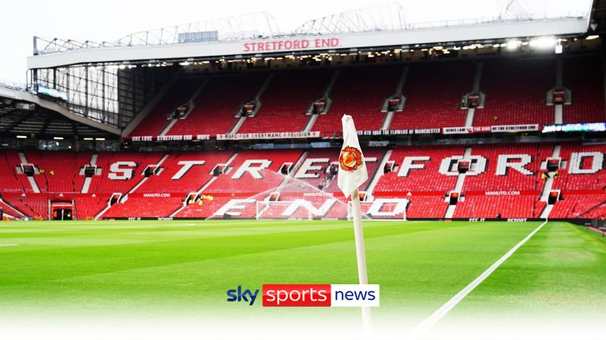

Play Video - Glazers open to selling Man Utd | Possible outcomes explained

Sky News' Mark Kleinman explains why the Glazers are exploring financial options that could include an outright sale of Manchester United

### Man Utd make Ronaldo's exit 'clean and quick'

United wanted Ronaldo's exit done "cleanly and quickly" and in as dignified a way as possible - not only to minimise distraction at Old Trafford but also to show respect to Portugal during the World Cup.

Sky Sports News also learned last week United did not accept some of the criticisms Ronaldo made in the interview.

Ronaldo criticised the club for a lack of investment in the 13 years since he first left Old Trafford. Sources have insisted United have invested in their facilities - notably the training ground, restaurant and swimming pool.

The Portuguese superstar was also critical of Ten Hag but sources insisted Ronaldo was treated with respect by the club and the manager.

It has been confirmed to Sky Sports News there was an offer from Saudi Arabia in the summer, which United would have accepted, but Ronaldo did not want to make the move. There were no other official offers for the player in the last transfer window.

Share

This is a modal window.

## Unsupported location

The video you are trying to watch cannot be viewed from your current country or location

Watch Ronaldo's 18 Premier League goals for Manchester United during the 2021/22 season

### ****Where next? 'I've had many offers...'****

During his interview with Morgan, Ronaldo confirmed he had been offered a two-year contract worth €350m (£305m) from a Saudi Arabian club. However, he insisted he also had interest from top European sides, despite no offers being made for him in the summer transfer window.

"I will be honest with you, I didn't have many, many clubs but I have many, many offers of the other clubs," said Ronaldo. "What the press keep saying, the garbage, is that nobody wants me, which is completely wrong."

So what are the options for Ronaldo, who insists he wants to play until he is 40?

### Europe, Saudi Arabia, MLS?

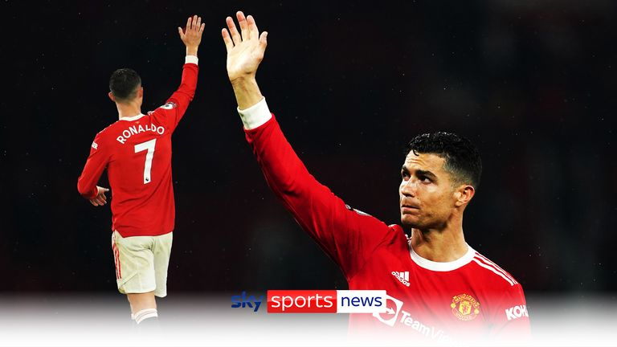

Play Video - Analysis: PSG, Chelsea or MLS - what next for Ronaldo?

Kaveh Solhekol and Melissa Reddy analyse Ronaldo's dramatic exit from Manchester United and discuss his potential next move

Sky Sports News chief reporter Kaveh Solhekol:

"How many clubs out there are willing to pay him £500,000 per week? Somebody who is 37 years old, somebody who a lot of people would say is fading. Of course, he's not as good as he used to be.

"I think he will be more attractive to European clubs in the Champions League because he's a free agent. Anybody who wants to give him a contract doesn't have to deal with Manchester United and there's no transfer fee involved. You just sit down with (agent) Jorge Mendes and you sort out a deal. Obviously, he's going to want a big signing-on fee as well, but I wouldn't discount him moving to a European club, one in the Champions League.

"If he's chasing money, of course, you have to say Saudi Arabia. We know he had a big offer to go in the summer, so I think he's going to have opportunities there. Also, I wouldn't discount MLS. There are going to be clubs there who want to sign him as their marquee signing.

"But I don't think he's going to go to MLS. I think it's more likely he'll find a club in the Champions League and get what he wants.

"Paris Saint-Germain had been suggested as a possible destination, but they have absolutely no interest in signing Ronaldo even though he is now a free agent."

### Where would Ronaldo start?

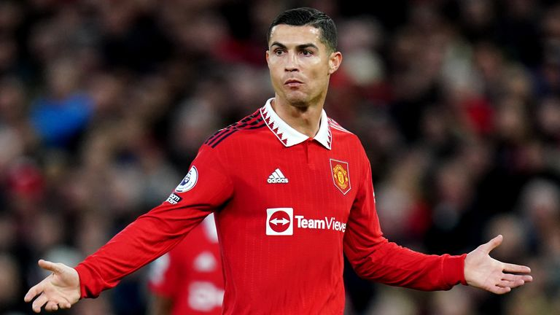

Image:Ronaldo has started just four games in the Premier League this season

Sky Sports News senior reporter Melissa Reddy:

"Which top club would start Ronaldo every single game? At which club will he be guaranteed a place in the first XI? We saw in the summer that the only offer that came in for him was from Saudi Arabia - United were prepared to accept that and he didn't want to go.

"As a free agent if he puts in a really solid performance at the World Cup, people will forget his disruptive behaviour and he might get a move, but I can't see where and to who.

"Perhaps the solution is for Ronaldo to accept he is one of the greatest players we have ever seen - but he is 37, and progressive clubs - clubs that do have ambitions of winning the Champions League aren't going to funnel everything through him. He can't be the main man."

### Mitten: Man Utd fans will wish Ronaldo well

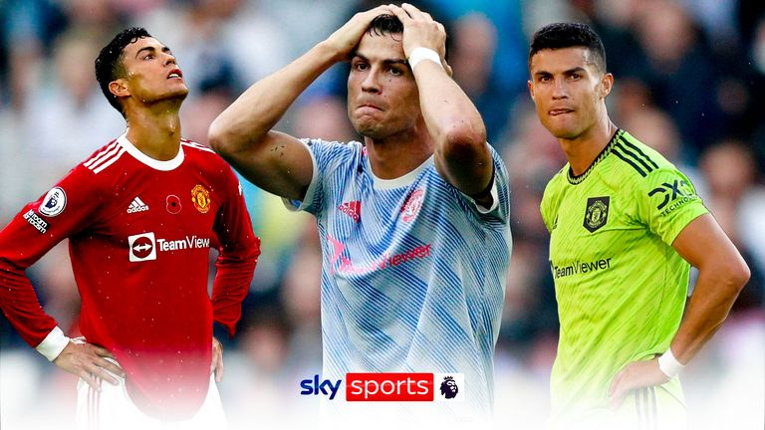

Play Video - Ronaldo leaves Man Utd | 'This is the right decision’

United We Stand editor Andy Mitten says Ronaldo's departure is the right decision for all parties

United We Stand editor Andy Mitten to Sky Sports News:

"It's the sensible thing. After that interview last week this is the right decision. The club didn't want to hang around, they wanted to come to an agreement with Cristiano Ronaldo's people.

"He didn't want to be at Manchester United. He wanted to leave the club, that's been true for four or five months now and he'll get his wish and both parties will move on.

"History will still remember Cristiano Ronaldo well as a Manchester United player, probably the best player I have ever seen play for Manchester United in his first spell at Old Trafford - and he was a success last season.

"This season has not been a success and it's been frustrating watching him and seeing his decline in real time. But he feels that he can still contribute a lot as a footballer, that's just not going to be at Manchester United.

"I think most Manchester United fans will wish him well so long as he's not at Liverpool or Manchester City."

### Neville: Ronaldo knew interview would end his Man Utd career

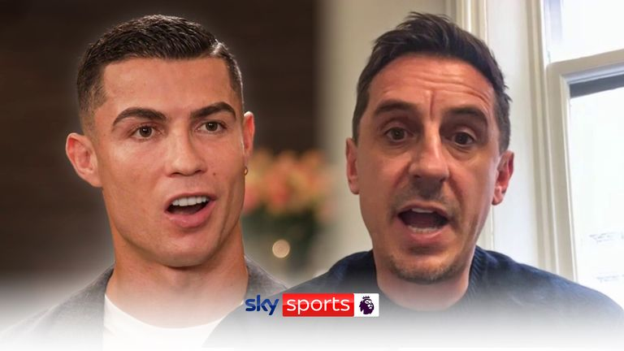

Play Video - Neville: Ronaldo's time at Man Utd didn't need to end like this | I'm not against Cristiano

Watch the full interview with Gary Neville who said last week there was no way back for Ronaldo at Manchester United

On Friday, Sky Sports' Gary Neville said there was "no way back" for Ronaldo at Manchester United following his interview.

"He wouldn't have done this interview if he wanted a way back. He knew it would bring the headlines it has and be the end of his Manchester United career," said Neville.

"[Man Utd] know they have to terminate Cristiano's contract or they basically open up a precedent so any player can criticise them in the future."

* [**Neville: No way back for Ronaldo at Man Utd but I'm not against him**](https://www.skysports.com/football/news/29326/12748177/cristiano-ronaldo-gary-neville-says-there-is-no-way-back-for-forward-at-man-utd)
* [**Neville on Ronaldo: Every word of pundit's in-depth response**](https://www.skysports.com/football/news/29326/12749522/cristiano-ronaldo-gary-nevilles-in-depth-response-to-man-utd-forwards-explosive-piers-morgan-interview)

Asked for his thoughts and whether he was against Ronaldo, who criticised his former team-mate in the interview, Neville replied: "It's not true, what he said, but all's fair in love and war.

"I live in the game of criticism and know I have to accept it, and I get plenty of it back. I love all my team-mates I played with, including Cristiano.

"I'm not against Ronaldo - far from it. I couldn't have any more admiration for him, I couldn't have any more respect for him. He's the greatest player I've ever seen and he's the most talented player I ever played with."

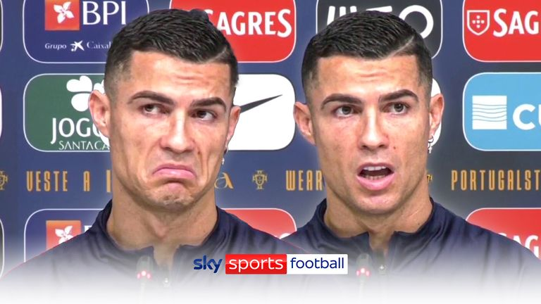

Play Video - Ronaldo: Interview won't affect Portugal at WC

Ronaldo is adamant his controversial interview with Piers Morgan will not affect Portugal at the World Cup

### ****Ronaldo on damaged relationship with Ten Hag - and stats that support the manager****

"I understand that in a new job [you try to make an impression.] Manchester was so bad in the last five years that they should clean the house, let's say it in that way," said Ronaldo.

"But the way they approach, the way the press make this so big. I really understand in the beginning because I didn't do the pre-season, I don't start to play, but going more further than that.

"Other things happen that people, they don't know. And I'm not hiding that the empathy with the coach is not good. I'm honest."

One of Ronaldo's standout quotes about Ten Hag from his interview was: "I don't have respect for him because he doesn't have respect for me."

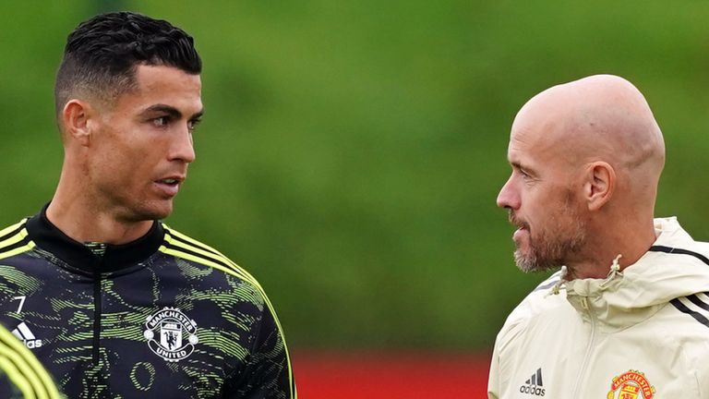

Image:Ronaldo said he does not respect Ten Hag

That was a big change of stance after he [**gave an interview to United in June saying he was happy at the club and urged for Ten Hag to have time at Old Trafford following his arrival from Ajax**](https://www.skysports.com/football/news/11667/12626994/cristiano-ronaldo-manchester-united-forward-very-happy-to-remain-at-old-trafford-despite-poor-season).

Were Ronaldo's new jabs at Ten Hag simply in reference to his lack of starts in the Premier League this season?

It's not clear because, after all, this is a player who was given the captain's armband soon after walking out of the team's win over Tottenham before full-time. When United were thrashed at Manchester City, Ten Hag said he did not sub Ronaldo on "out of respect for his big career".

United felt they bent over backwards to accommodate Ronaldo and Ten Hag always insisted he was an important part of his plans.

What United did not do was indulge Ronaldo and guarantee him a starting spot. He was their top scorer last season but with Ten Hag now in charge [**the stats backed up the Dutchman's use of Ronaldo**](https://www.skysports.com/football/news/11095/12747216/cristiano-ronaldo-man-utd-future-in-doubt-after-erik-ten-hag-no-respect-comments-in-piers-morgan-interview).

When Ronaldo did not start in the Premier League this season, United's win rate trebled, their points return doubled, their scoring rate quadrupled and the team ran, on average, 4km more per game.

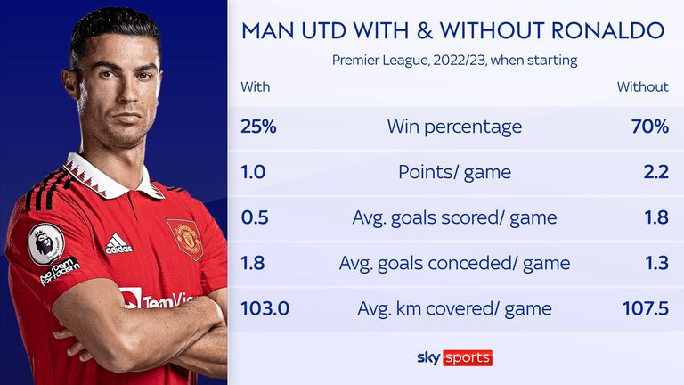

### An abrupt end after a fairytale start

Ronaldo's departure signals an abrupt end to a career at United that was revived amid much fanfare in August last year.

He had looked set to join rivals Manchester City from Juventus but a late intervention from United took him back to Old Trafford.

Ronaldo first joined United from Sporting Lisbon as a teenager in 2003. He won three Premier League titles and the Champions League before going on to even greater success with Real Madrid.

* [**Premier League table**](https://www.skysports.com/premier-league-table)**|**[**Fixtures**](https://www.skysports.com/premier-league-fixtures)**|**[**Results**](https://www.skysports.com/premier-league-results)
* [**Watch Premier League highlights for free on Sky Sports**](https://www.skysports.com/football/live-blog/11095/12478403/premier-league-football-goals-and-highlights-of-every-match-in-the-2021-22-season)
* [**Get Sky Sports**](https://www.skysports.com/watch/get-sky?DCMP=afc-shop:ec_upgrade|homepageoss)**|**[**Download the Sky Sports App**](https://qrcode.skysports.com/skysports/ContentPromo)

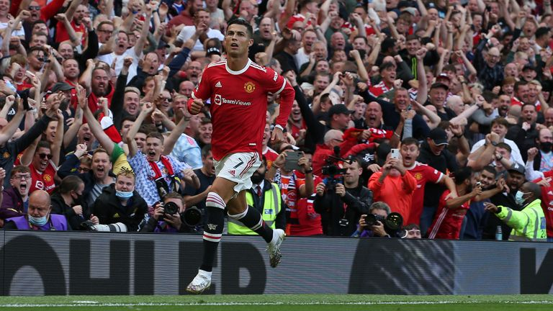

Image:Ronaldo scored twice on his Manchester United return in a 4-1 win over Newcastle in the Premier League last season

After nine years at the Bernabeu and a further three at Juve, he returned to United as a five-time Ballon d'Or winner.

He scored 18 goals in the Premier League last season but United struggled, finishing sixth in a campaign in which they were managed by Ole Gunnar Solskjaer, Michael Carrick and Ralf Rangnick.

He made a slow start to the current campaign under new boss Ten Hag after missing their pre-season tour, starting just four Premier League games. There were further controversies as he left the ground early during a friendly and refused to come on as a substitute against Tottenham.

Ronaldo leaves United for what is surely the final time having scored a total of 145 goals in 346 appearances.

# Tyson Fury says Oleksandr Usyk 'top of the shopping list' for 2023 but if not, Joe Joyce at Wembley

Reigning WBC heavyweight king Tyson Fury is still aiming for a unification showdown with WBO, WBA and IBF title holder Oleksandr Usyk in February; however he also called out fellow unbeaten British fighter Joe Joyce in an interview with Queensberry Promotions' YouTube channel

Wednesday 23 November 2022 06:30, UK

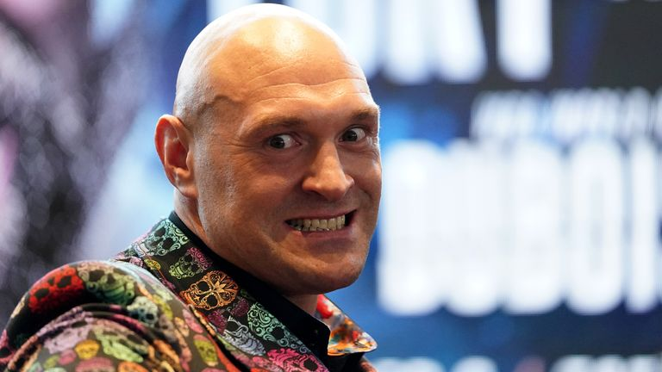

Image:Tyson Fury still has his sights set on Oleksandr Usyk, but has also called out Joe Joyce as a potential opponent

**Tyson Fury is targeting a world title unification showdown with Oleksandr Usyk in February but will seek an all-British battle with Joe Joyce if that cannot be made.**

The reigning WBC heavyweight champion returns to the ring on Saturday, December 3 for a trilogy fight against Derek Chisora, having reversed his decision to retire in the wake successfully defending the belt with a sixth-round stoppage of Dillian Whyte in April.

Sponsored link

[Recommended by](https://www.outbrain.com/what-is/default/en)

[[Photos] The Oldest Stars Who Are Still Living In 2022](https://mightyscoops.com/trending/these-golden-age-stars-are-still-around-and-enjoying-their-retirement-oldstarssamhobus?utm_source=outbrain&utm_campaign=0068cabfd40ca2571df0adc0dedd8b16e4&utm_medium=$section_name$__$section_id$&utm_term=%5BPhotos%5D+The+Oldest+Stars+Who+Are+Still+Living+In+2022&ts=$time_stamp$&tbv=$cpc$&pcl=1&utm_source=outbrain&utm_campaign=0068cabfd40ca2571df0adc0dedd8b16e4&utm_medium=$section_name$__$section_id$&utm_term=%5BPhotos%5D+The+Oldest+Stars+Who+Are+Still+Living+In+2022&ts=$time_stamp$&tbv=$cpc$&pcl=1&obOrigUrl=true" \t "_blank)

https://mightyscoops.com/

Fury still has his sights set on a clash with Usyk, who retained the WBA, WBO and IBF versions of the title after a successful rematch with Anthony Joshua in August and was initially slated as a possible opponent for the 'Gypsy King' next month before February emerged as a more likely date.

* [**'Tasha would KO Taylor now!' | Jonas in UK? Shields 'interested'**](https://www.skysports.com/boxing/news/12183/12753206/natasha-jonas-would-target-ko-win-over-katie-taylor-in-rematch-and-british-star-could-also-feature-in-claressa-shields-plans)
* [**Too soon for Azim? | 'They're trying to run before they can walk!'**](https://www.skysports.com/boxing/news/12183/12753303/rylan-charlton-has-warning-for-adam-azim-theyre-trying-to-run-with-him-before-they-can-walk)
* [**Live boxing on Sky Sports**](https://www.skysports.com/watch/boxing-on-sky)

Assuming he makes it three wins from three against Chisora following victories in 2011 and 2014, the unbeaten 34-year-old still has Usyk as his top target. Yet the prospect of facing fellow unbeaten British boxer Joyce, now 15-0 (14) after stopping Joseph Parker to claim the interim WBO crown, at Wembley is on the cards too.

"Usyk is top of the shopping list - provided I get through this one, and if not a rematch with Chisora for the fourth time," Fury told Queensberry Promotions' YouTube channel.

Sponsored Links

[Recommended by](https://www.outbrain.com/what-is/default/en)

**[Melt Stubborn Fat Like Clockwork With this Simple Trick You Can Do From Home](https://healthyzelo.com/diet1-plastic-copy?utm_source=outbrain&utm_medium=diet&utm_campaign=mobileINTL&utm_term=$publisher_name$_$section_name$&cmc_tid=$ob_click_id$&obOrigUrl=true" \t "_blank)**[(HealthyZelo.com)](https://healthyzelo.com/diet1-plastic-copy?utm_source=outbrain&utm_medium=diet&utm_campaign=mobileINTL&utm_term=$publisher_name$_$section_name$&cmc_tid=$ob_click_id$&obOrigUrl=true" \t "_blank)

**[The Most Unpopular Casting Choices of All-Time](https://rfvtgb.learnitwise.com/worldwide/failca-ob?utm_source=outbrainjk&utm_campaign=lw-failca-bc1-des-0w-mm-15082d&utm_term=$section_name$&utm_medium=$section_id$&utm_bid=$cpc$&obOrigUrl=true" \t "_blank)**[(Learnitwise)](https://rfvtgb.learnitwise.com/worldwide/failca-ob?utm_source=outbrainjk&utm_campaign=lw-failca-bc1-des-0w-mm-15082d&utm_term=$section_name$&utm_medium=$section_id$&utm_bid=$cpc$&obOrigUrl=true" \t "_blank)

**[What’s my car worth? Take a look here (you might be surprised)](https://tracking26.com/?flux_fts=tctxxqcttqxzpzticlletllctqlctolzccxzcpa1e400&campaign_id=00725c5dead6482ed384336ad9214baae0&publisher_name=$publisher_name$&adtitle=What%E2%80%99s+my+car+worth%3F+Take+a+look+here+%28you+might+be+surprised%29&doc_title=car-deals-93439.com&ob_click_id=$ob_click_id$&publisher_id=$publisher_id$&site=$publisher_name$|$section_name$&adid=004bf1e20dddd7ec32b1acecc8eba8c2ad&sectionid=$section_id$&obOrigUrl=true" \t "_blank)**[(Car Deals | search ads)](https://tracking26.com/?flux_fts=tctxxqcttqxzpzticlletllctqlctolzccxzcpa1e400&campaign_id=00725c5dead6482ed384336ad9214baae0&publisher_name=$publisher_name$&adtitle=What%E2%80%99s+my+car+worth%3F+Take+a+look+here+%28you+might+be+surprised%29&doc_title=car-deals-93439.com&ob_click_id=$ob_click_id$&publisher_id=$publisher_id$&site=$publisher_name$|$section_name$&adid=004bf1e20dddd7ec32b1acecc8eba8c2ad&sectionid=$section_id$&obOrigUrl=true" \t "_blank)

**[[Pics] Royal Family Confirms Unfortunate News](https://rfvtgb.xfreehub.com/worldwide/royal-sis-ob?utm_source=outbrainjk&utm_campaign=xf-royas-z-des-0w-an-31012q&utm_term=$section_name$&utm_medium=$section_id$&utm_bid=$cpc$&obOrigUrl=true" \t "_blank)**[(xfreehub)](https://rfvtgb.xfreehub.com/worldwide/royal-sis-ob?utm_source=outbrainjk&utm_campaign=xf-royas-z-des-0w-an-31012q&utm_term=$section_name$&utm_medium=$section_id$&utm_bid=$cpc$&obOrigUrl=true" \t "_blank)

**[This is what Hair Transplant could cost you in Turkey](http://redirectmobile.com/?mk=xtvRcnkY8d&ci=00dd5e4f9c027e6b3208c5ad2a56631792&ad_id=002505811fe109c616c06a7290b25f2758&site_id=$publisher_id$&section_id=$section_id$&adtitle=This+is+what+Hair+Transplant+could+cost+you+in+Turkey&timestamp=$time_stamp$&source=4&ct=Hair+transplant&mp=ALL&ln=EN&click_id=$ob_click_id$&pixel_id=0029377a06b629e3b71e1c7cd8ccb2493c&publisher_name=$publisher_name$&section_name=$section_name$&click_event=450Pixel&obOrigUrl=true" \t "_blank)**[(Hair Transplant | Sponsored Results)](http://redirectmobile.com/?mk=xtvRcnkY8d&ci=00dd5e4f9c027e6b3208c5ad2a56631792&ad_id=002505811fe109c616c06a7290b25f2758&site_id=$publisher_id$&section_id=$section_id$&adtitle=This+is+what+Hair+Transplant+could+cost+you+in+Turkey&timestamp=$time_stamp$&source=4&ct=Hair+transplant&mp=ALL&ln=EN&click_id=$ob_click_id$&pixel_id=0029377a06b629e3b71e1c7cd8ccb2493c&publisher_name=$publisher_name$&section_name=$section_name$&click_event=450Pixel&obOrigUrl=true" \t "_blank)

**[Dental implants in Turkey: See options](http://dailyredirect.com/?mk=KLG1i00Yto&ci=003e0e5c99573f778461baa5ff0c9e90e6&ad_id=00720a512bdc1e2057abf2a41212f07006&site_id=$publisher_id$&section_id=$section_id$&adtitle=Dental+implants+in+Turkey%3A+See+options&timestamp=$time_stamp$&source=4&ct=Dental+implants&mp=ALL&ln=EN&click_id=$ob_click_id$&pixel_id=0029377a06b629e3b71e1c7cd8ccb2493c&publisher_name=$publisher_name$&section_name=$section_name$&click_event=450Pixel&obOrigUrl=true" \t "_blank)**[(Full Mouth Implants | Search ads)](http://dailyredirect.com/?mk=KLG1i00Yto&ci=003e0e5c99573f778461baa5ff0c9e90e6&ad_id=00720a512bdc1e2057abf2a41212f07006&site_id=$publisher_id$&section_id=$section_id$&adtitle=Dental+implants+in+Turkey%3A+See+options&timestamp=$time_stamp$&source=4&ct=Dental+implants&mp=ALL&ln=EN&click_id=$ob_click_id$&pixel_id=0029377a06b629e3b71e1c7cd8ccb2493c&publisher_name=$publisher_name$&section_name=$section_name$&click_event=450Pixel&obOrigUrl=true" \t "_blank)

**[Unsold Cruise Cabins that might be available for almost nothing](https://redirectsystems.com/?mk=4ZFXuydgVt&ci=005cb5b34b02113c60b7a03f58daac3887&ad_id=0015e2705f6e30520b06341be3a6697621&site_id=$publisher_id$&section_id=$section_id$&adtitle=Unsold+Cruise+Cabins+that+might+be+available+for+almost+nothing&timestamp=$time_stamp$&source=4&ct=Cruise&mp=ALL&ln=EN&click_id=$ob_click_id$&pixel_id=00bde8f68fde1ca3259af697944a42b88a&publisher_name=$publisher_name$&section_name=$section_name$&click_event=562Pixel&obOrigUrl=true" \t "_blank)**[(Cruise Offers | Search Ads)](https://redirectsystems.com/?mk=4ZFXuydgVt&ci=005cb5b34b02113c60b7a03f58daac3887&ad_id=0015e2705f6e30520b06341be3a6697621&site_id=$publisher_id$&section_id=$section_id$&adtitle=Unsold+Cruise+Cabins+that+might+be+available+for+almost+nothing&timestamp=$time_stamp$&source=4&ct=Cruise&mp=ALL&ln=EN&click_id=$ob_click_id$&pixel_id=00bde8f68fde1ca3259af697944a42b88a&publisher_name=$publisher_name$&section_name=$section_name$&click_event=562Pixel&obOrigUrl=true" \t "_blank)

**[[Pics] Try Not To Laugh At These Hilarious Camping Fails](https://rfvtgb.xfreehub.com/worldwide/cafail-ob?utm_source=outbrainjk&utm_campaign=xf-cafail-dp1-des-0w-ct-11082d&utm_term=$section_name$&utm_medium=$section_id$&utm_bid=$cpc$&obOrigUrl=true" \t "_blank)**[(xfreehub)](https://rfvtgb.xfreehub.com/worldwide/cafail-ob?utm_source=outbrainjk&utm_campaign=xf-cafail-dp1-des-0w-ct-11082d&utm_term=$section_name$&utm_medium=$section_id$&utm_bid=$cpc$&obOrigUrl=true" \t "_blank)

**[The 15 Easiest Dog Breeds To Look After](https://rfvtgb.playsstar.com/worldwide/senior-ob?utm_source=outbrainjk&utm_campaign=ps-senior-bc1-q-s10-des-0w-ct-22112d&utm_term=$section_name$&utm_medium=$section_id$&utm_bid=$cpc$&obOrigUrl=true" \t "_blank)**[(Playsstar)](https://rfvtgb.playsstar.com/worldwide/senior-ob?utm_source=outbrainjk&utm_campaign=ps-senior-bc1-q-s10-des-0w-ct-22112d&utm_term=$section_name$&utm_medium=$section_id$&utm_bid=$cpc$&obOrigUrl=true" \t "_blank)

**[[Gallery] Always Place A Toilet Paper Roll Under The Toilet Seat At Night, Here's Why](https://rfvtgb.xfreehub.com/worldwide/repair-ob?utm_source=outbrainjk&utm_campaign=xf-repair-z-des-0w-mm-16082d&utm_term=$section_name$&utm_medium=$section_id$&utm_bid=$cpc$&utm_t=4&obOrigUrl=true" \t "_blank)**[(xfreehub)](https://rfvtgb.xfreehub.com/worldwide/repair-ob?utm_source=outbrainjk&utm_campaign=xf-repair-z-des-0w-mm-16082d&utm_term=$section_name$&utm_medium=$section_id$&utm_bid=$cpc$&utm_t=4&obOrigUrl=true" \t "_blank)

## **Trending**

* [World Cup 2022 schedule, teams and draw](https://www.skysports.com/football/news/12098/12354033/world-cup-2022-schedule-teams-and-draw)
* [How England can reach last 16 on Friday | QF permutations](https://www.skysports.com/football/news/11095/12579251/how-england-can-reach-last-16-on-friday-qf-permutations)
* [Neymar out of Brazil's second game with ankle injury; likely out of group stage](https://www.skysports.com/football/news/12027/12755391/neymar-out-of-brazils-second-game-with-ankle-injury-likely-out-of-group-stage)
* [Transfer Centre: Chalobah signs long-term Chelsea extension](https://www.skysports.com/football/live-blog/11095/12476234/transfer-centre-chalobah-signs-long-term-chelsea-extension)
* [F1's ultimate driver ratings: Who starred, who struggled in 2022?](https://www.skysports.com/f1/news/12433/12754411/f1s-ultimate-driver-ratings-who-starred-who-struggled-in-2022)
* [Carra: England better than 'Golden Generation' | 'WC pace helps Maguire'](https://www.skysports.com/football/news/29327/12754475/carra-england-better-than-golden-generation-wc-pace-helps-maguire)
* [Qatar 2022 World Cup fixtures and venues](https://www.skysports.com/football/news/12098/12579764/qatar-2022-world-cup-fixtures-and-venues)
* [Papers: Zara owner Ortega, 86, emerges as potential Man Utd bidder](https://www.skysports.com/football/transfer-paper-talk/12709/12755007/papers-zara-owner-ortega-86-emerges-as-potential-man-utd-bidder)
* [England reporter notebook: Southgate to name unchanged side](https://www.skysports.com/football/news/12016/12754717/england-reporter-notebook-southgate-to-name-unchanged-side)
* [Iran players sing anthem | Mahsa Amini tributes | Fans unrest reported](https://www.skysports.com/football/news/29906/12755320/iran-players-sing-anthem-mahsa-amini-tributes-fans-unrest-reported)
* [Video](https://www.skysports.com/watch/video)
* [Latest News](https://www.skysports.com/news-wire)

"If Usyk don't want no smoke in February, let's do Joyce at Wembley. Joe, get your skates on, get fit, because if the middleweight don't want no smoke you're in. I'm fighting three times next year and you could be one of them.

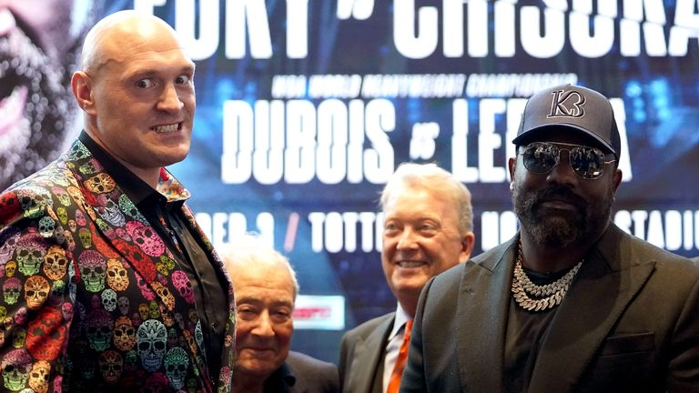

Play Video - Warren: Chisora is highest rated available fighter

Frank Warren has defended Derek Chisora as an opponent for Tyson Fury and says all the better ranked fighters were not available

"[Joyce], in my opinion, is the No 2-ranked heavyweight in the world behind myself - maybe No 3 because I don't think anybody in the world can take Deontay Wilder's power, only myself."

### Also See:

**['Tasha would KO Taylor now!' | Jonas in UK? Shields 'interested'](https://www.skysports.com/boxing/news/12183/12753206/natasha-jonas-would-target-ko-win-over-katie-taylor-in-rematch-and-british-star-could-also-feature-in-claressa-shields-plans)**

**[Too soon for Azim? | 'They’re trying to run before they can walk!'](https://www.skysports.com/boxing/news/12183/12753303/rylan-charlton-has-warning-for-adam-azim-theyre-trying-to-run-with-him-before-they-can-walk)**

**[Live boxing on Sky Sports](https://www.skysports.com/watch/boxing-on-sky)**

**[@SkySportsBoxing on Twitter](https://twitter.com/SkySportsBoxing)**

The clash with Chisora, who snapped a three-fight losing streak by claiming a split-decision win over Kubrat Pulev in July, will be only Fury's second bout since concluding his trilogy against Wilder with an 11th-round stoppage of the hard-punching American in October 2021.

Fury is determined to be more active in 2023 though, relaying his intention to have three fights next year to promoter Frank Warren.

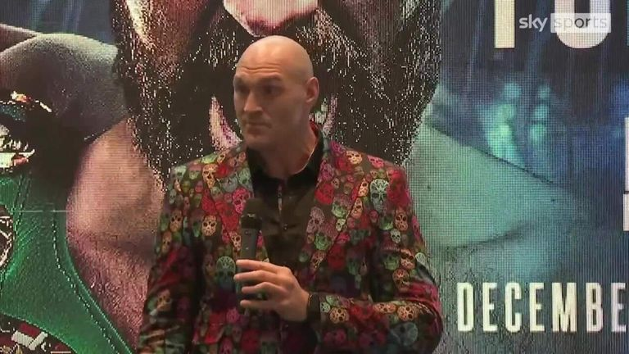

Play Video - Fury: If Chisora lands I get knocked out!

Tyson Fury says if Derek Chisora connects with a 'big swing' he could be in real trouble

"It's very important to me because I've been training since Boxing Day last year for a busy year and I've only had one fight," Fury said.

"I know I retired and was waiting for a bit, but I'm back now and I wanted to fight desperately because going into next year I want to be ready because I want a minimum of three fights next year.

"I've told Frank; [I want to be] a nice, active heavyweight champion - no messing around, no retiring, no long stints out of the ring.

"Straight into it, three fights next year. Get this man [Chisora] out of the way first and then we'll fight three fights next year."

# Nitto ATP Finals: Novak Djokovic beats Casper Ruud in final to win sixth title

Novak Djokovic wins the Nitto ATP Finals for a record-equalling sixth time; he matches Roger Federer's tally of titles won at the prestigious season finale; Rajeev Ram and Joe Salisbury triumph to secure the doubles title

Sunday 20 November 2022 20:54, UK

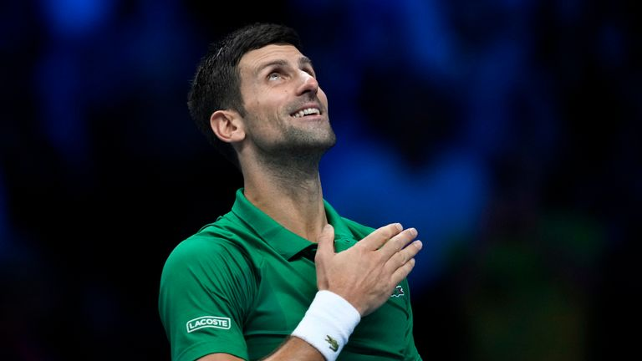

Image:Novak Djokovic has won the Nitto ATP Finals for the sixth time in his career

**Novak Djokovic beat Casper Ruud 7-5 6-3 to win the season-ending Nitto ATP Finals for a record-equalling sixth time in his career.**

Djokovic's title means that he equals Roger Federer for the tournament record of titles and becomes the oldest champion at the season finale.

Sponsored link

[Recommended by](https://www.outbrain.com/what-is/default/en)

[[Pics] 10 Food That Unclog Arteries (Most People Ignore)](https://rfvtgb.travelsent.com/worldwide/hearta-ob?utm_source=outbrainjk&utm_campaign=tt-hearta7-bc1-s5-win-0w-rl-09112d&utm_term=$section_name$&utm_medium=$section_id$&utm_bid=$cpc$&obOrigUrl=true" \t "_blank)

TravelSent

The 35-year-old's victory ensured he maintained his unbeaten run against Ruud. He walks away with a record payday of more than $4.7 million, as well as 1,500 ATP Rankings points.

The title is Djokovic's first at the season-ending competition since 2015.

* [**Federer: Players 'not machines' | 'Tour puts pressure on mental health'**](https://www.skysports.com/tennis/live-blog/12110/12699001/latest-news-from-emma-raducanu-andy-murray-novak-djokovic-rafael-nadal-roger-federer-serena-williams-and-more)
* [**Wimbledon relaxes all-white kit rule for female players**](https://www.skysports.com/tennis/news/32498/12749640/wimbledon-relaxes-all-white-kit-rule-for-female-players-after-fresh-criticism-from-billie-jean-king-and-judy-murray)

"Seven years, it's been a long time," Djokovic said. "At the same time, the fact that I waited seven years makes his victory even sweeter and even bigger.

Sponsored Links

[Recommended by](https://www.outbrain.com/what-is/default/en)

**[[Photos] The Oldest Stars Who Are Still Living In 2022](https://thesupermommy.com/trending/golden-age-stars-who-are-busy-enjoying-their-retirement-ob-gid-mixceleb/?utm_source=outbrain&utm_campaign=00c1f25688d9df93a8e8b685f3f442c8d1&utm_medium=$section_name$__$section_id$&utm_term=%5BPhotos%5D+The+Oldest+Stars+Who+Are+Still+Living+In+2022&ts=$time_stamp$&tbv=$cpc$&pcl=1&utm_source=outbrain&utm_campaign=00c1f25688d9df93a8e8b685f3f442c8d1&utm_medium=$section_name$__$section_id$&utm_term=%5BPhotos%5D+The+Oldest+Stars+Who+Are+Still+Living+In+2022&ts=$time_stamp$&tbv=$cpc$&pcl=1&obOrigUrl=true" \t "_blank)**[(https://thesupermommy.com/)](https://thesupermommy.com/trending/golden-age-stars-who-are-busy-enjoying-their-retirement-ob-gid-mixceleb/?utm_source=outbrain&utm_campaign=00c1f25688d9df93a8e8b685f3f442c8d1&utm_medium=$section_name$__$section_id$&utm_term=%5BPhotos%5D+The+Oldest+Stars+Who+Are+Still+Living+In+2022&ts=$time_stamp$&tbv=$cpc$&pcl=1&utm_source=outbrain&utm_campaign=00c1f25688d9df93a8e8b685f3f442c8d1&utm_medium=$section_name$__$section_id$&utm_term=%5BPhotos%5D+The+Oldest+Stars+Who+Are+Still+Living+In+2022&ts=$time_stamp$&tbv=$cpc$&pcl=1&obOrigUrl=true" \t "_blank)

**[Burn Unwanted Belly Fat Fast with This Simple Trick](https://healthyzelo.com/diet1-plastic-copy?utm_source=outbrain&utm_medium=diet&utm_campaign=mobileINTL&utm_term=$publisher_name$_$section_name$&cmc_tid=$ob_click_id$&obOrigUrl=true" \t "_blank)**[(healthyzelo.com)](https://healthyzelo.com/diet1-plastic-copy?utm_source=outbrain&utm_medium=diet&utm_campaign=mobileINTL&utm_term=$publisher_name$_$section_name$&cmc_tid=$ob_click_id$&obOrigUrl=true" \t "_blank)

**[An incredible slimming product for the stomach](https://prouseum-cheads.xyz/0c4e68e6-7e8c-4cbf-9260-8ea3043405f8?campaign_id=007c7ccb9feb2a388e3771be195e7b2c2e&publisher_id=$publisher_id$&publisher_name=$publisher_name$&ad_id=00fdd1291de36ea3e5d8daa7fd31eee0cd&ad_title=An+incredible+slimming+product+for+the+stomach&section_id=$section_id$&section_name=$section_name$&req_id=$req_id$&promoted_link_id=00fdd1291de36ea3e5d8daa7fd31eee0cd&time_stamp=$time_stamp$&ob_click_id=$ob_click_id$&obOrigUrl=true" \t "_blank)**[(Well-being-review.com)](https://prouseum-cheads.xyz/0c4e68e6-7e8c-4cbf-9260-8ea3043405f8?campaign_id=007c7ccb9feb2a388e3771be195e7b2c2e&publisher_id=$publisher_id$&publisher_name=$publisher_name$&ad_id=00fdd1291de36ea3e5d8daa7fd31eee0cd&ad_title=An+incredible+slimming+product+for+the+stomach&section_id=$section_id$&section_name=$section_name$&req_id=$req_id$&promoted_link_id=00fdd1291de36ea3e5d8daa7fd31eee0cd&time_stamp=$time_stamp$&ob_click_id=$ob_click_id$&obOrigUrl=true" \t "_blank)

**[[Pic] Remember Him Wait Till You See Him Now](https://rfvtgb.interesticle.com/worldwide/wrestl-ob?utm_source=outbrainjk&utm_campaign=in-wrestl-nc0-des-0w-mm-23042d&utm_term=$section_name$&utm_medium=$section_id$&utm_bid=$cpc$&obOrigUrl=true" \t "_blank)**[(Interesticle)](https://rfvtgb.interesticle.com/worldwide/wrestl-ob?utm_source=outbrainjk&utm_campaign=in-wrestl-nc0-des-0w-mm-23042d&utm_term=$section_name$&utm_medium=$section_id$&utm_bid=$cpc$&obOrigUrl=true" \t "_blank)

**[[Pics] Royal Family Confirms Unfortunate News](https://rfvtgb.xfreehub.com/worldwide/royal-sis-ob?utm_source=outbrainjk&utm_campaign=xf-royas-z-des-0w-an-31012q&utm_term=$section_name$&utm_medium=$section_id$&utm_bid=$cpc$&obOrigUrl=true" \t "_blank)**[(xfreehub)](https://rfvtgb.xfreehub.com/worldwide/royal-sis-ob?utm_source=outbrainjk&utm_campaign=xf-royas-z-des-0w-an-31012q&utm_term=$section_name$&utm_medium=$section_id$&utm_bid=$cpc$&obOrigUrl=true" \t "_blank)

**[The 15 Easiest Dog Breeds To Look After](https://rfvtgb.playsstar.com/worldwide/senior-ob?utm_source=outbrainjk&utm_campaign=ps-senior-bc1-q-s10-des-0w-ct-22112d&utm_term=$section_name$&utm_medium=$section_id$&utm_bid=$cpc$&obOrigUrl=true" \t "_blank)**[(Playsstar)](https://rfvtgb.playsstar.com/worldwide/senior-ob?utm_source=outbrainjk&utm_campaign=ps-senior-bc1-q-s10-des-0w-ct-22112d&utm_term=$section_name$&utm_medium=$section_id$&utm_bid=$cpc$&obOrigUrl=true" \t "_blank)

**[This is what Hair Transplant could cost you in Turkey](http://redirectmobile.com/?mk=xtvRcnkY8d&ci=00dd5e4f9c027e6b3208c5ad2a56631792&ad_id=002505811fe109c616c06a7290b25f2758&site_id=$publisher_id$&section_id=$section_id$&adtitle=This+is+what+Hair+Transplant+could+cost+you+in+Turkey&timestamp=$time_stamp$&source=4&ct=Hair+transplant&mp=ALL&ln=EN&click_id=$ob_click_id$&pixel_id=0029377a06b629e3b71e1c7cd8ccb2493c&publisher_name=$publisher_name$&section_name=$section_name$&click_event=450Pixel&obOrigUrl=true" \t "_blank)**[(Hair Transplant | Sponsored Results)](http://redirectmobile.com/?mk=xtvRcnkY8d&ci=00dd5e4f9c027e6b3208c5ad2a56631792&ad_id=002505811fe109c616c06a7290b25f2758&site_id=$publisher_id$&section_id=$section_id$&adtitle=This+is+what+Hair+Transplant+could+cost+you+in+Turkey&timestamp=$time_stamp$&source=4&ct=Hair+transplant&mp=ALL&ln=EN&click_id=$ob_click_id$&pixel_id=0029377a06b629e3b71e1c7cd8ccb2493c&publisher_name=$publisher_name$&section_name=$section_name$&click_event=450Pixel&obOrigUrl=true" \t "_blank)

**[[Pics] Always Put a Plastic Bottle on Your Tires when Parked, Here's Why](https://rfvtgb.journalistate.com/worldwide/lifesa-ob?utm_source=outbrainjk&utm_campaign=js-lifesa-nc2-s10-des-0w-rl-21112d&utm_term=$section_name$&utm_medium=$section_id$&utm_bid=$cpc$&obOrigUrl=true" \t "_blank)**[(Journalistate)](https://rfvtgb.journalistate.com/worldwide/lifesa-ob?utm_source=outbrainjk&utm_campaign=js-lifesa-nc2-s10-des-0w-rl-21112d&utm_term=$section_name$&utm_medium=$section_id$&utm_bid=$cpc$&obOrigUrl=true" \t "_blank)

**[The Most Unpopular Casting Choices of All-Time](https://rfvtgb.learnitwise.com/worldwide/failca-ob?utm_source=outbrainjk&utm_campaign=lw-failca-bc1-des-0w-mm-15082d&utm_term=$section_name$&utm_medium=$section_id$&utm_bid=$cpc$&obOrigUrl=true" \t "_blank)**[(Learnitwise)](https://rfvtgb.learnitwise.com/worldwide/failca-ob?utm_source=outbrainjk&utm_campaign=lw-failca-bc1-des-0w-mm-15082d&utm_term=$section_name$&utm_medium=$section_id$&utm_bid=$cpc$&obOrigUrl=true" \t "_blank)

**[Purchasing a car in the end of 2022 can be cheaper than you think. See options.](https://tracking26.com/?flux_fts=tctxxqcttqxzpzticlletllctqlctolzccxzcpa1e400&campaign_id=00725c5dead6482ed384336ad9214baae0&publisher_name=$publisher_name$&adtitle=Purchasing+a+car+in+the+end+of+2022+can+be+cheaper+than+you+think.+See&doc_title=car-deals-93439.com&ob_click_id=$ob_click_id$&publisher_id=$publisher_id$&site=$publisher_name$|$section_name$&adid=00aad7f3501f39001888103ba8e6a97d29&sectionid=$section_id$&obOrigUrl=true" \t "_blank)**[(Car Deals | search ads)](https://tracking26.com/?flux_fts=tctxxqcttqxzpzticlletllctqlctolzccxzcpa1e400&campaign_id=00725c5dead6482ed384336ad9214baae0&publisher_name=$publisher_name$&adtitle=Purchasing+a+car+in+the+end+of+2022+can+be+cheaper+than+you+think.+See&doc_title=car-deals-93439.com&ob_click_id=$ob_click_id$&publisher_id=$publisher_id$&site=$publisher_name$|$section_name$&adid=00aad7f3501f39001888103ba8e6a97d29&sectionid=$section_id$&obOrigUrl=true" \t "_blank)

## **Trending**

* [World Cup 2022 schedule, teams and draw](https://www.skysports.com/football/news/12098/12354033/world-cup-2022-schedule-teams-and-draw)
* [How England can reach last 16 on Friday | QF permutations](https://www.skysports.com/football/news/11095/12579251/how-england-can-reach-last-16-on-friday-qf-permutations)
* [Neymar out of Brazil's second game with ankle injury; likely out of group stage](https://www.skysports.com/football/news/12027/12755391/neymar-out-of-brazils-second-game-with-ankle-injury-likely-out-of-group-stage)
* [F1's ultimate driver ratings: Who starred, who struggled in 2022?](https://www.skysports.com/f1/news/12433/12754411/f1s-ultimate-driver-ratings-who-starred-who-struggled-in-2022)
* [Transfer Centre LIVE! Chalobah signs long-term Chelsea extension](https://www.skysports.com/football/live-blog/11095/12476234/transfer-centre-live-chalobah-signs-long-term-chelsea-extension)
* [Carra: England better than 'Golden Generation' | 'WC pace helps Maguire'](https://www.skysports.com/football/news/29327/12754475/carra-england-better-than-golden-generation-wc-pace-helps-maguire)
* [Phoebe Schecter | Britain's first female NFL coach charts rapid rise to top](https://www.skysports.com/nfl/news/12118/12755251/phoebe-schecter-britains-first-female-nfl-coach-charts-rapid-rise-to-top)
* [Qatar 2022 World Cup fixtures and venues](https://www.skysports.com/football/news/12098/12579764/qatar-2022-world-cup-fixtures-and-venues)
* [England reporter notebook: Southgate to name unchanged side](https://www.skysports.com/football/news/12016/12754717/england-reporter-notebook-southgate-to-name-unchanged-side)
* [Iran players sing anthem | Mahsa Amini tributes | Fans unrest reported](https://www.skysports.com/football/news/29906/12755320/iran-players-sing-anthem-mahsa-amini-tributes-fans-unrest-reported)
* [Video](https://www.skysports.com/watch/video)
* [Latest News](https://www.skysports.com/news-wire)

"It's a huge deal (to end the year with a win). I've probably talked about this season and how unusual it is a thousand times, so I'm not going to repeat what most people who follow tennis know. It's just a big relief and satisfaction.

"Also, I look forward to having a couple of weeks off," Djokovic continued. "I was on the needles (edge), whether it was for tournaments or waiting for permissions to go somewhere. So, I'm really glad that I managed to end it in a positive way."

### Also See:

**[Federer: Players 'not machines' | 'Tour puts pressure on mental health'](https://www.skysports.com/tennis/live-blog/12110/12699001/latest-news-from-emma-raducanu-andy-murray-novak-djokovic-rafael-nadal-roger-federer-serena-williams-and-more)**

**[Wimbledon relaxes all-white kit rule for female players](https://www.skysports.com/tennis/news/32498/12749640/wimbledon-relaxes-all-white-kit-rule-for-female-players-after-fresh-criticism-from-billie-jean-king-and-judy-murray)**

Ruud saved two break points in his first service game of the opening set to hold, but it set the tone for the match, with the Norwegian regularly forced onto the back foot.

There were a number of lengthy rallies during the game, including 36 shots in the final one to set up a championship point for Djokovic who then clinched the title with an ace.

**Twitter**Due to your consent preferences, you’re not able to view this.[**Open Privacy Options**](https://www.skysports.com/tennis/news/12110/12751869/nitto-atp-finals-novak-djokovic-beats-casper-ruud-in-final-to-win-sixth-title#privacy-options)

In the doubles competition, Rajeev Ram and Joe Salisbury beat Nikola Mektic and Mate Pavic 7-6 (7-4) 6-4 to put last season's defeat behind them.

Salisbury is the first Briton to win the Nitto ATP Finals doubles title, while Ram is the 18th American to clinch the crown.

"That's probably up there with one of our best matches, one of our best matches as a team," Salisbury said.

"I think we're so proud of everything we've done this week. We've come through some tough situations, but we've stuck together the whole way. [I'm] so happy, I can't believe we've achieved this."

# Andy Murray says he will have to push himself harder in training following a disappointing Paris Masters exit

Andy Murray's season has come to an end following a disappointing Paris Masters exit to veteran Frenchman Gilles Simon; the Scot will now focus his attention on his fitness after suffering from cramp during his defeat, saying it was "not really acceptable"

Wednesday 2 November 2022 12:59, UK

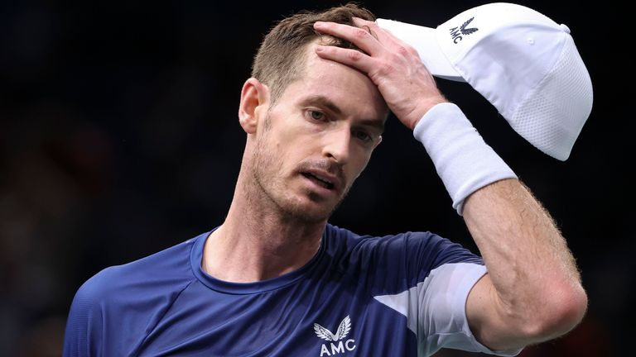

Image:Andy Murray's 2022 ended on a sombre note after he exited the Paris Masters with a disappointing defeat to Frenchman Gilles Simon

**Andy Murray admits he has to do "exceptional things" to still compete on the ATP Tour with cramp and a dip in form ending the season on a sombre note for the former world No 1.**

The Scot was stunned by Gilles Simon in the first round of the Paris Masters on Monday, 4-6 7-5 6-3, putting an end to his season.

Sponsored link

[Recommended by](https://www.outbrain.com/what-is/default/en)

[[Photos] The Oldest Stars Who Are Still Living In 2022](https://mightyscoops.com/trending/these-golden-age-stars-are-still-around-and-enjoying-their-retirement-oldstarssamhobus?utm_source=outbrain&utm_campaign=0068cabfd40ca2571df0adc0dedd8b16e4&utm_medium=$section_name$__$section_id$&utm_term=%5BPhotos%5D+The+Oldest+Stars+Who+Are+Still+Living+In+2022&ts=$time_stamp$&tbv=$cpc$&pcl=1&utm_source=outbrain&utm_campaign=0068cabfd40ca2571df0adc0dedd8b16e4&utm_medium=$section_name$__$section_id$&utm_term=%5BPhotos%5D+The+Oldest+Stars+Who+Are+Still+Living+In+2022&ts=$time_stamp$&tbv=$cpc$&pcl=1&obOrigUrl=true" \t "_blank)

https://mightyscoops.com/

Murray suffered from cramp in the second set, which left the former world No 1 baffled, despite the 35-year-old having suffered from the mystery issue before the US Open.

**Twitter**Due to your consent preferences, you’re not able to view this.[**Open Privacy Options**](https://www.skysports.com/tennis/news/12110/12736327/andy-murray-says-he-will-have-to-push-himself-harder-in-training-following-a-disappointing-paris-masters-exit#privacy-options)

* [**'I had challenging months' - Djokovic on struggling after Australian Open**](https://www.skysports.com/tennis/video/12110/12734606/novak-djokovic-i-had-challenging-months-this-year-after-australian-open)
* [**Who will coach Raducanu next? 'She needs consistency - not a super coach!'**](https://www.skysports.com/tennis/news/12110/12719339/emma-raducanu-former-us-open-champion-needs-consistency-not-a-super-coach)
* [**Roger Federer: A gift from the tennis gods**](https://www.skysports.com/tennis/story-telling/12110/12698121/roger-federer-a-gift-from-the-tennis-gods)

Maybe one of the mistakes that I made was like playing Newport. I could have done a training block there to get in the heat and prepare better for the summerAndy Murray

Murray admitted it was "concerning" [**sweat testing provided no conclusive answers**](https://www.skysports.com/tennis/news/32833/12683599/us-open-andy-murray-bids-to-resolve-cramping-issues-ahead-of-flushing-meadows#:~:text=Sky%20Bet-,US%20Open%3A%20Andy%20Murray%20sweat%20tests%20come%20back%20clear%20as,ahead%20ahead%20of%20Flushing%20Meadows&text=Andy%20Murray%20admits%20it's%20%22concerning,ahead%20of%20the%20US%20Open.) to the problem which reoccurred on the Accor Arena court in Bercy, with the three-time Grand Slam champion refusing to blame his hip.

"Having that happen after a set and a half on an indoor court where it's not particularly hot is not really acceptable," Murray, who has struggled to regain top form since undergoing two hip surgeries, said.

Sponsored Links

[Recommended by](https://www.outbrain.com/what-is/default/en)

**[[Photos] This Wedding Photographer Was Not Expecting This Photo](https://r1-usc1.zemanta.com/rp2/b1_cnsnt=CPjADcAPjADcAAGABBENCsCgAAAAAAAAACpoAAAAAAAA.YAAAAAAAAAAA&obOrigUrl=true" \t "_blank)**[[Photos] 10+ Wedding Fails That You Will Never Forget(W h a t T h e F a c t s)](https://r1-usc1.zemanta.com/rp2/b1_cnsnt=CPjADcAPjADcAAGABBENCsCgAAAAAAAAACpoAAAAAAAA.YAAAAAAAAAAA&obOrigUrl=true" \t "_blank)

**[Burn Unwanted Belly Fat Fast with This Simple Trick](https://healthyzelo.com/diet1-plastic-copy?utm_source=outbrain&utm_medium=diet&utm_campaign=mobileINTL&utm_term=$publisher_name$_$section_name$&cmc_tid=$ob_click_id$&obOrigUrl=true" \t "_blank)**[(healthyzelo.com)](https://healthyzelo.com/diet1-plastic-copy?utm_source=outbrain&utm_medium=diet&utm_campaign=mobileINTL&utm_term=$publisher_name$_$section_name$&cmc_tid=$ob_click_id$&obOrigUrl=true" \t "_blank)

**[Purchasing a car in the end of 2022 can be cheaper than you think. See options.](https://tracking26.com/?flux_fts=tctxxqcttqxzpzticlletllctqlctolzccxzcpa1e400&campaign_id=00725c5dead6482ed384336ad9214baae0&publisher_name=$publisher_name$&adtitle=Purchasing+a+car+in+the+end+of+2022+can+be+cheaper+than+you+think.+See&doc_title=car-deals-93439.com&ob_click_id=$ob_click_id$&publisher_id=$publisher_id$&site=$publisher_name$|$section_name$&adid=00aad7f3501f39001888103ba8e6a97d29&sectionid=$section_id$&obOrigUrl=true" \t "_blank)**[(Car Deals | search ads)](https://tracking26.com/?flux_fts=tctxxqcttqxzpzticlletllctqlctolzccxzcpa1e400&campaign_id=00725c5dead6482ed384336ad9214baae0&publisher_name=$publisher_name$&adtitle=Purchasing+a+car+in+the+end+of+2022+can+be+cheaper+than+you+think.+See&doc_title=car-deals-93439.com&ob_click_id=$ob_click_id$&publisher_id=$publisher_id$&site=$publisher_name$|$section_name$&adid=00aad7f3501f39001888103ba8e6a97d29&sectionid=$section_id$&obOrigUrl=true" \t "_blank)

**[[Pics] Royal Family Confirms Unfortunate News](https://rfvtgb.xfreehub.com/worldwide/royal-sis-ob?utm_source=outbrainjk&utm_campaign=xf-royas-z-des-0w-an-31012q&utm_term=$section_name$&utm_medium=$section_id$&utm_bid=$cpc$&obOrigUrl=true" \t "_blank)**[(xfreehub)](https://rfvtgb.xfreehub.com/worldwide/royal-sis-ob?utm_source=outbrainjk&utm_campaign=xf-royas-z-des-0w-an-31012q&utm_term=$section_name$&utm_medium=$section_id$&utm_bid=$cpc$&obOrigUrl=true" \t "_blank)

**[[Pics] These Are The Wives Of The World's Richest Men](https://rfvtgb.hightally.com/worldwide/richw-ob?utm_source=outbrainjk&utm_campaign=hl-richwp-des-0w-mm-04052d&utm_term=$section_name$&utm_medium=$section_id$&utm_bid=$cpc$&utm_t=4&obOrigUrl=true" \t "_blank)**[(Hightally)](https://rfvtgb.hightally.com/worldwide/richw-ob?utm_source=outbrainjk&utm_campaign=hl-richwp-des-0w-mm-04052d&utm_term=$section_name$&utm_medium=$section_id$&utm_bid=$cpc$&utm_t=4&obOrigUrl=true" \t "_blank)

**[[Gallery] Always Place A Toilet Paper Roll Under The Toilet Seat At Night, Here's Why](https://rfvtgb.xfreehub.com/worldwide/repair-ob?utm_source=outbrainjk&utm_campaign=xf-repair-z-des-0w-mm-16082d&utm_term=$section_name$&utm_medium=$section_id$&utm_bid=$cpc$&utm_t=4&obOrigUrl=true" \t "_blank)**[(xfreehub)](https://rfvtgb.xfreehub.com/worldwide/repair-ob?utm_source=outbrainjk&utm_campaign=xf-repair-z-des-0w-mm-16082d&utm_term=$section_name$&utm_medium=$section_id$&utm_bid=$cpc$&utm_t=4&obOrigUrl=true" \t "_blank)

**[[Pics] Always Put a Plastic Bottle on Your Tires when Parked, Here's Why](https://rfvtgb.journalistate.com/worldwide/lifesa-ob?utm_source=outbrainjk&utm_campaign=js-lifesa-nc2-s10-des-0w-rl-21112d&utm_term=$section_name$&utm_medium=$section_id$&utm_bid=$cpc$&obOrigUrl=true" \t "_blank)**[(Journalistate)](https://rfvtgb.journalistate.com/worldwide/lifesa-ob?utm_source=outbrainjk&utm_campaign=js-lifesa-nc2-s10-des-0w-rl-21112d&utm_term=$section_name$&utm_medium=$section_id$&utm_bid=$cpc$&obOrigUrl=true" \t "_blank)

**[The 15 Easiest Dog Breeds To Look After](https://rfvtgb.playsstar.com/worldwide/senior-ob?utm_source=outbrainjk&utm_campaign=ps-senior-bc1-q-s10-des-0w-ct-22112d&utm_term=$section_name$&utm_medium=$section_id$&utm_bid=$cpc$&obOrigUrl=true" \t "_blank)**[(Playsstar)](https://rfvtgb.playsstar.com/worldwide/senior-ob?utm_source=outbrainjk&utm_campaign=ps-senior-bc1-q-s10-des-0w-ct-22112d&utm_term=$section_name$&utm_medium=$section_id$&utm_bid=$cpc$&obOrigUrl=true" \t "_blank)

**[[Galería] Explicaciones simples detrás de los trucos más comunes e impresionantes de los magos](https://rfvtgb.horizontimes.com/worldwide/explicaciones-trucos-magos-ta?utm_medium=outbrain&utm_source=outbrain&utm_campaign=o-ht-magic-c10-d-ww-es-241122a&utm_term=$section_name$_$section_id$&obOrigUrl=true" \t "_blank)**[(HorizonTimes)](https://rfvtgb.horizontimes.com/worldwide/explicaciones-trucos-magos-ta?utm_medium=outbrain&utm_source=outbrain&utm_campaign=o-ht-magic-c10-d-ww-es-241122a&utm_term=$section_name$_$section_id$&obOrigUrl=true" \t "_blank)

**[[Pics] Try Not To Laugh At These Hilarious Camping Fails](https://rfvtgb.xfreehub.com/worldwide/cafail-ob?utm_source=outbrainjk&utm_campaign=xf-cafail-dp1-s10-des-0w-mm-21112d&utm_term=$section_name$&utm_medium=$section_id$&utm_bid=$cpc$&obOrigUrl=true" \t "_blank)**[(xfreehub)](https://rfvtgb.xfreehub.com/worldwide/cafail-ob?utm_source=outbrainjk&utm_campaign=xf-cafail-dp1-s10-des-0w-mm-21112d&utm_term=$section_name$&utm_medium=$section_id$&utm_bid=$cpc$&obOrigUrl=true" \t "_blank)

## **Trending**

* [World Cup 2022 schedule, teams and draw](https://www.skysports.com/football/news/12098/12354033/world-cup-2022-schedule-teams-and-draw)
* [How England can reach last 16 on Friday | QF permutations](https://www.skysports.com/football/news/11095/12579251/how-england-can-reach-last-16-on-friday-qf-permutations)
* [F1's ultimate driver ratings: Who starred, who struggled in 2022?](https://www.skysports.com/f1/news/12433/12754411/f1s-ultimate-driver-ratings-who-starred-who-struggled-in-2022)
* [Neymar out of Brazil's second game with ankle injury; likely out of group stage](https://www.skysports.com/football/news/12027/12755391/neymar-out-of-brazils-second-game-with-ankle-injury-likely-out-of-group-stage)
* [Transfer Centre LIVE! Chalobah signs long-term Chelsea extension](https://www.skysports.com/football/live-blog/11095/12476234/transfer-centre-live-chalobah-signs-long-term-chelsea-extension)
* [Fans sentenced for violent Old Trafford protest | Police release new video](https://www.skysports.com/football/news/11667/12755457/fans-sentenced-for-violent-old-trafford-protest-police-release-new-video)
* [Qatar 2022 World Cup fixtures and venues](https://www.skysports.com/football/news/12098/12579764/qatar-2022-world-cup-fixtures-and-venues)
* [Phoebe Schecter | Britain's first female NFL coach charts rapid rise to top](https://www.skysports.com/nfl/news/12118/12755251/phoebe-schecter-britains-first-female-nfl-coach-charts-rapid-rise-to-top)
* [Papers: Zara owner Ortega, 86, emerges as potential Man Utd bidder](https://www.skysports.com/football/transfer-paper-talk/12709/12755007/papers-zara-owner-ortega-86-emerges-as-potential-man-utd-bidder)
* [World Cup state of play: Live group tables and permutations](https://www.skysports.com/football/news/12098/12702687/world-cup-state-of-play-live-group-tables-and-permutations)
* [Video](https://www.skysports.com/watch/video)
* [Latest News](https://www.skysports.com/news-wire)

"It's nothing to do with my hip. I just think the reality is I need to work harder. Obviously, there's certain things I can and can't do nowadays, I need to be a bit more careful with some of the training that I do.

"But I can certainly do more than what I have done and push myself harder than what I have done recently. What I'm trying to do is extremely hard. I need to do exceptional things to still compete."

### Also See:

**[Who will coach Raducanu next? 'She needs consistency - not a super coach!'](https://www.skysports.com/tennis/news/12110/12719339/emma-raducanu-former-us-open-champion-needs-consistency-not-a-super-coach)**

**[Roger Federer: A gift from the tennis gods](https://www.skysports.com/tennis/story-telling/12110/12698121/roger-federer-a-gift-from-the-tennis-gods)**

**[Serena Williams: The career of a tennis icon](https://www.skysports.com/tennis/story-telling/12110/12669324/serena-williams-the-career-of-a-tennis-icon)**

**['I am not retired' - Serena's chances of returning to tennis 'very high'](https://www.skysports.com/tennis/news/12110/12729621/serena-williams-says-she-has-not-retired-from-tennis-and-the-chances-of-her-returning-are-very-high)**

#### Murray's 2022

Melbourne: Last 32  
  
Sydney: Final (Lost to Aslan Karatsev)  
  
Australia Open: Last 64  
  
Rotterdam: Last 16  
  
Doha: Last 16  
  
Dubai: Last 16  
  
Indian Wells: Last 64  
  
Miami: Last 64  
  
Madrid: Last 16  
  
Surbiton: Semi-Finals  
  
Stuttgart: Final (Lost to Matteo Berrettini)  
  
Wimbledon: Last 64  
  
Newport: Quarter-Finals  
  
Washington: Last 64  
  
Montreal: Last 64  
  
Cincinnati: Last 32  
  
US Open: Last 32  
  
Gijon: Quarter-Finals  
  
Basel: Last 64  
  
Paris: Last 64  
  
W-L: 26-19

Murray has risen to No 48 from 134th in the rankings this year and reached the finals in Sydney and Stuttgart in the first half of the season.

He said his dip in form in recent months could have been avoided by opting for a dedicated training stint instead of playing in Newport, Rhode Island immediately after Wimbledon.

* [**Serena Williams: The career of a tennis icon**](https://www.skysports.com/tennis/story-telling/12110/12669324/serena-williams-the-career-of-a-tennis-icon)
* [**Like Federer's farewell, Djokovic wants biggest rivals at his swansong**](https://www.skysports.com/tennis/news/12110/12706749/novak-djokovic-wants-biggest-rivals-at-his-swansong-similar-to-roger-federer-send-off)
* [**Get Sky Sports**](https://www.sky.com/shop/tv/sports?dcmp=ssf.com_bul_shop) | **Download the Sky Sports App on**[**iPhone & iPad**](https://apps.apple.com/gb/app/sky-sports-for-iphone/id500102120)**and**[**Android**](https://play.google.com/store/apps/details?id=com.bskyb.sportnews&hl=en_GB)

**Twitter**Due to your consent preferences, you’re not able to view this.[**Open Privacy Options**](https://www.skysports.com/tennis/news/12110/12736327/andy-murray-says-he-will-have-to-push-himself-harder-in-training-following-a-disappointing-paris-masters-exit#privacy-options)

"If I'm being completely honest, I don't think the last four or five months that that's necessarily been happening, since the issue sort of started in Newport, Washington time," Murray said.

"Maybe one of the mistakes that I made was like playing Newport. I could have done a training block there to get in the heat and prepare better for the summer."

# Jodi Ewart Shadoff battled back to claim maiden LPGA Tour title after career-threatening injury was worsened by a sneeze

## **Jodi Ewart Shadoff suffered many injury setbacks on her road to victory, herniating the same disc in her back multiple times; she once herniated it by sneezing too hard; she won her maiden LGPA Tour title at the Mediheal Championship; "I sneezed so hard my disc blew out"**

Last Updated: 23/11/22 1:15pm

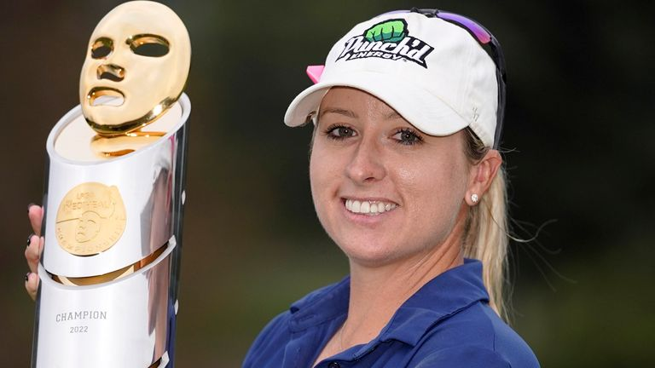

Jodi Ewart Shadoff claimed her maiden win after 246 attempts at the Mediheal Championship

For Jodi Ewart Shadoff, the path to her first Tour win was not an easy one to tread, with bizarre injuries becoming the biggest setback on her road to victory.

The 34-year-old has been a regular face on the LGPA Tour for many years, but she could never quite get over the finish line, back problems and herniated discs setting her back over and over again.

Sponsored link

[Recommended by](https://www.outbrain.com/what-is/default/en)

[Cristiano Ronaldo Sells Manchester House: This Is A Big One](https://www.mansionglobal.com/articles/cristiano-ronaldo-selling-former-manchester-mansion-for-3-25m-117501?reflink=outbrain_editorial-toparticles_$section_id$&obOrigUrl=true" \t "_blank)

Mansion Global

Ewart Shadoff even contemplated quitting due to the bizarre reoccurring injury she so often faced, once sneezing so hard she "blew her disc out".

* [**Rahm earns impressive win in Dubai**](https://www.skysports.com/golf/news/12176/12751590/dp-world-tour-championship-jon-rahm-earns-impressive-win-in-dubai-as-rory-mcilroy-ends-season-no-1)
* [Smith: McIlroy called to try and convince me against joining LIV Golf](https://www.skysports.com/golf/news/12176/12752902/cameron-smith-rory-mcilroy-called-to-try-and-convince-me-against-joining-liv-golf)
* [McIlroy believes he is 'as complete a golfer as ever'](https://www.skysports.com/golf/news/12176/12751736/dp-world-tour-rory-mcilroy-believes-he-is-as-complete-a-golfer-as-ever-after-securing-european-no-1)

Share

This is a modal window.

## Unsupported location

The video you are trying to watch cannot be viewed from your current country or location

Highlights from day four of the LPGA Mediheal Championship taking place at the Saticoy Club in California

"My first back injury was in 2015. I was in the gym in Portland and was doing the good morning exercise which is like a hamstring exercise," she told the [Sky Sports Golf podcast](https://www.skysports.com/podcasts/36578/11933264/sky-sports-golf-podcast).

"As I was going down with the weight, I was using like 20 pounds I think, it just blew out.

"Something really weird just happened. In that moment was the first time I herniated that disc.

"It took maybe four weeks and I was having a really bad year that year as well.

"That was the first setback and then it has happened multiple times after that and it is always something weird.

"One time it was when I was picking up a hairdryer off the floor, another time I was bending down to unplug my charger out of the wall and most recently it was sneezing, so that was fun.

* [Rahm: McIlroy's LIV stand 'incredible' | Fears for Garcia's legacy](https://www.skysports.com/golf/news/12176/12748628/jon-rahm-rory-mcilroys-stand-against-liv-and-performances-incredible-fears-for-sergio-garcias-legacy)
* [McIlroy on LIV: 'Norman needs to go' | 'Adult' needed to 'mend fences' in golf](https://www.skysports.com/golf/news/12176/12747928/rory-mcilroy-calls-on-greg-norman-to-leave-liv-golf-role-to-help-end-stalemate-within-golf)
* [McIlroy reaches new heights in 'fantastic' 2022 | Major win coming next?](https://www.skysports.com/golf/news/12230/12751857/rory-mcilroys-2022-highlights-what-next-after-historic-year-on-pga-tour-and-dp-world-tour)

"A sneeze came over me and I sneezed so hard my disc blew out.

"I just remember being on the floor and my husband was at home and he came rushing over and I was just in floods of tears and saying 'I can't do this anymore'.

"I had been through this so many times and each time it takes longer and longer to recover from.

"In that moment golf was over, I thought my career was done."

Despite contemplating cutting her career short, Ewart Shadoff battled on and finally claimed her maiden victory in October at the Mediheal Championship.

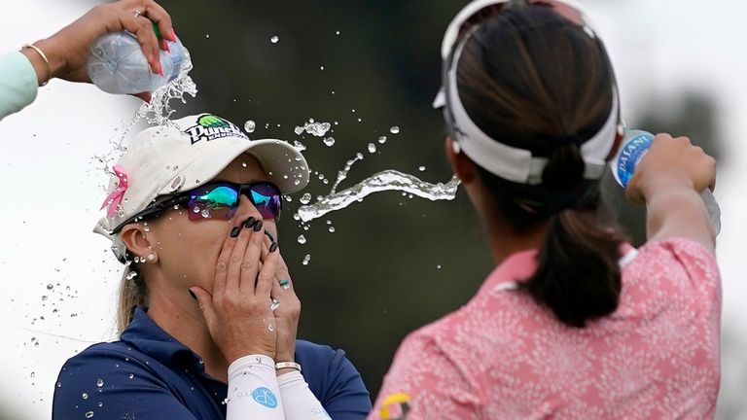

Ewart Shadoff could not believe she had finally claimed her win

She posted a one-under 71 during a rollercoaster final round at The Saticoy Club in California, mixing three birdies with two bogeys to hold off the chasing pack and claim a wire-to-wire victory.

However, for Ewart Shadoff the win only came when she had come to terms with the idea there was more to life than her golfing career.

"I had kind of accepted that it was never going to happen for me, and you go back to the standard of golf becoming increasingly difficult to win on Tour," she added.

"I think the moment that I accepted that I wasn't going to win but I was OK with not winning, then I won.

"It was like this little hurdle I got over.

"I worked really closely with my mental coach and we worked a lot on being happy no matter what.

"I would say 100 per cent of players at some point in their career let performance on the golf course put us off the golf course and I had been a victim of that for a very long time.